Generate New Digit Images – Report

**Part 1 -** Generate a set of 10,000 random 1's and save the parameter vectors for each '1'.

* To achieve this goal, I first had to read in the 874 images that were a good fit.
* I then had to get its e-values, their means and their variances.
* The code that I used to do this was as follows:

*# read in data*

*final = scan("final")*

*# create matrix of data*

*final = matrix(final,12,874)*

*# exclude first + last*

*results2 = final[2:11,]*

*# get the variance*

*resvar = apply(results2,1,var)*

*# divide by the standard deviation*

*results3 = results2 / sqrt(resvar)*

*# get the variance*

*cr=var(t(results3))*

*# get the e-values + e-vectors*

*er = eigen(cr)*

*# plot the e-values*

*plot(er$values, col = "red", xlim = c(0, 50), ylim = c(0,5.1))*

*# do PCA on the e-value's and plot the first 2*

*p=t(results3[1:10,]) %*% er$vectors[,1:10]*

*dev.new()*

*plot(p[,1],p[,2], col = "red")*

*#get their means*

*mp=apply(p,2,mean)*

* I then had to create a function that draws a stroke:

*stroke = function(x1,y1,theta,len,width)*

*{*

*x=c(1:16)*

*y=c(1:16)*

*x=x-x1*

*y=y-y1*

*u1=x*cos(theta)*

*u2=y*sin(theta)*

*u=matrix(u1,16,16)+t(matrix(u2,16,16))*

*v1=-x*sin(theta)*

*v2=y*cos(theta)*

*v=matrix(v1,16,16)+t(matrix(v2,16,16))*

*m = (v > 0 & v < len)*

*exp(-u*u/width) * m*

*}*

* After this was done, I was able to work on creating the 10,000 random 1’s.
* These digits were created and then displayed using the following code:

*# initialise rp, the parameter vector, params and the image vector, ims*

*rp = mp + ((i+5) * c(1,rep(0,9)))*

*params2 = matrix(0,10,1)*

*ims = matrix(0, 256, 1)*

*for(i in seq(0, -10, -0.001))*

*{*

*# create a random normal distribution for each e-value*

*rp[1] = rnorm(1,mp[1],(er$values[1])^(0.5))*

*rp[2] = rnorm(1,mp[2],(er$values[2])^(0.5))*

*rp[3] = rnorm(1,mp[3],(er$values[3])^(0.5))*

*rp[4] = rnorm(1,mp[4],(er$values[4])^(0.5))*

*rp[5] = rnorm(1,mp[5],(er$values[5])^(0.5))*

*rp[6] = rnorm(1,mp[6],(er$values[6])^(0.5))*

*rp[7] = rnorm(1,mp[7],(er$values[7])^(0.5))*

*rp[8] = rnorm(1,mp[8],(er$values[8])^(0.5))*

*rp[9] = rnorm(1,mp[9],(er$values[9])^(0.5))*

*rp[10] = rnorm(1,mp[10],(er$values[10])^(0.5))*

*rp3 = rp %*% t(er$vectors[,1:10])*

*rec = rp3 * sqrt(resvar)*

*# put constraints on the images*

*rec[1] = max(min(17, rec[1]),10) #x1*

*rec[2] = max(min(17, rec[1]), 10) #y1*

*rec[3] = min(max(rec[3], 0.55 * pi), pi * 0.8) #theta1*

*rec[4] = min(max(10.0, rec[4]), 22.0) #len1*

*rec[5] = min(max(rec[5], 0.5), 5.0) #width1*

*rec[6] = max(min(17, rec[6]), 10, rec[1]) #x2*

*rec[7] = max(min(17, rec[7]), 10, rec[2]) #y2*

*rec[8] = min(max(rec[8], rec[3] + 0.17 * pi, 0.8 * pi), pi * 1.06) #theta2*

*rec[9] = min(max(10.0, rec[9]), 18.0) #len2*

*rec[10] = min(max(rec[10], 0.5), 7.0) #width2*

*# plot the strokes*

*s1 = stroke(rec[1], rec[2], rec[3], rec[4], rec[5])*

*s2 = stroke(rec[6], rec[7], rec[8], rec[9], rec[10])*

*im = s1 + s2*

*im[im > 1] = 1*

*# plot the images*

*image(c(1:16), c(1:16), 256 * im, col = gray(c(0:256) / 256))*

*readline()*

*}*

* After these random 1’s were generated, I just had to save the parameter vectors and the image vectors for each generated 1.
* I did this by replacing the last 2 lines of the above for loop with the following lines and then running the loop again.

*ims = cbind(ims, matrix(im[,16:1], 256, 1))*

*params = cbind(params,rec[1:10])*

* “dim(ims)” was 10,002 x 256 as it contained the first initialised row of all zeros and “dim(params)” was 10,002 x 10 as it also contained the first initialised row of all zeros so I removed these initial rows and transposed these matricies with the following lines of code:

*# delete the first row and transpose the matrix*

*params = params[,2:10002]*

*params = t(params)*

*ims=ims[,2:10002]*

*ims = t(ims)*

* The variable “params” then contained the parameter vectors for each of the 10,001 randomly generated 1’s.

**Part 2 -** Blur the images with width = 1.

* To blur these images, I had to first create a gaussian array with width 1.
* This was done with the following code:

*width = 1*

*ii = c(0:15)*

*ii[9:16] = 17 - c(9:16)*

*ii = ii^2*

*ex = exp(-ii / width)*

*gau = ex %*% t(ex)*

*image(c(1:16), c(1:16), 256 * gau, col = gray(c(0:256) / 256))*

* Then to blur the images, I used this gaussian array along with the “ims” variable of the image vectors created above.
* I first ran through each image and blurred it, and then displayed it so I could see the effect this had on each image.
* This was done using the following code:

*x2 = ims*

*x = ims*

*for(i in c(1:10001))*

*{*

*z = matrix(as.numeric(x[i,]), 16, 16)*

*rt = fft(z)*

*ft = ft * gau*

*z2 = fft(ft, inverse = T)*

*# view the image*

*image(c(1:16), c(1:16), abs(z2), col = gray(c(0:256) / 256))*

*readline()*

*}*

* I only looked through a few images and then stopped the loop and replaced the last 2 lines of the loop with the following code in order to save each blurred images image vector to a variable for further use, after this I re-ran the loop.

*x2[i,] = matrix(abs(z2), 1, 256)*

**Part 3 -** Compute the eigenvalues and eigenvectors of the blurred images. Project the blurred images onto the eigenvectors and plot the points with respect to the first two eigenvectors.

* Computing the eigenvalues and eigenvectors was easy so I got them and then plotted the eigenvalues.

*# get the variance*

*cb = var(x2)*

*# get the e-values + e-vectors*

*eb = eigen(cb)*

*# plot the e-values*

*plot(eb$values)*

* The plotted eigenvalues are shown in the diagram below.

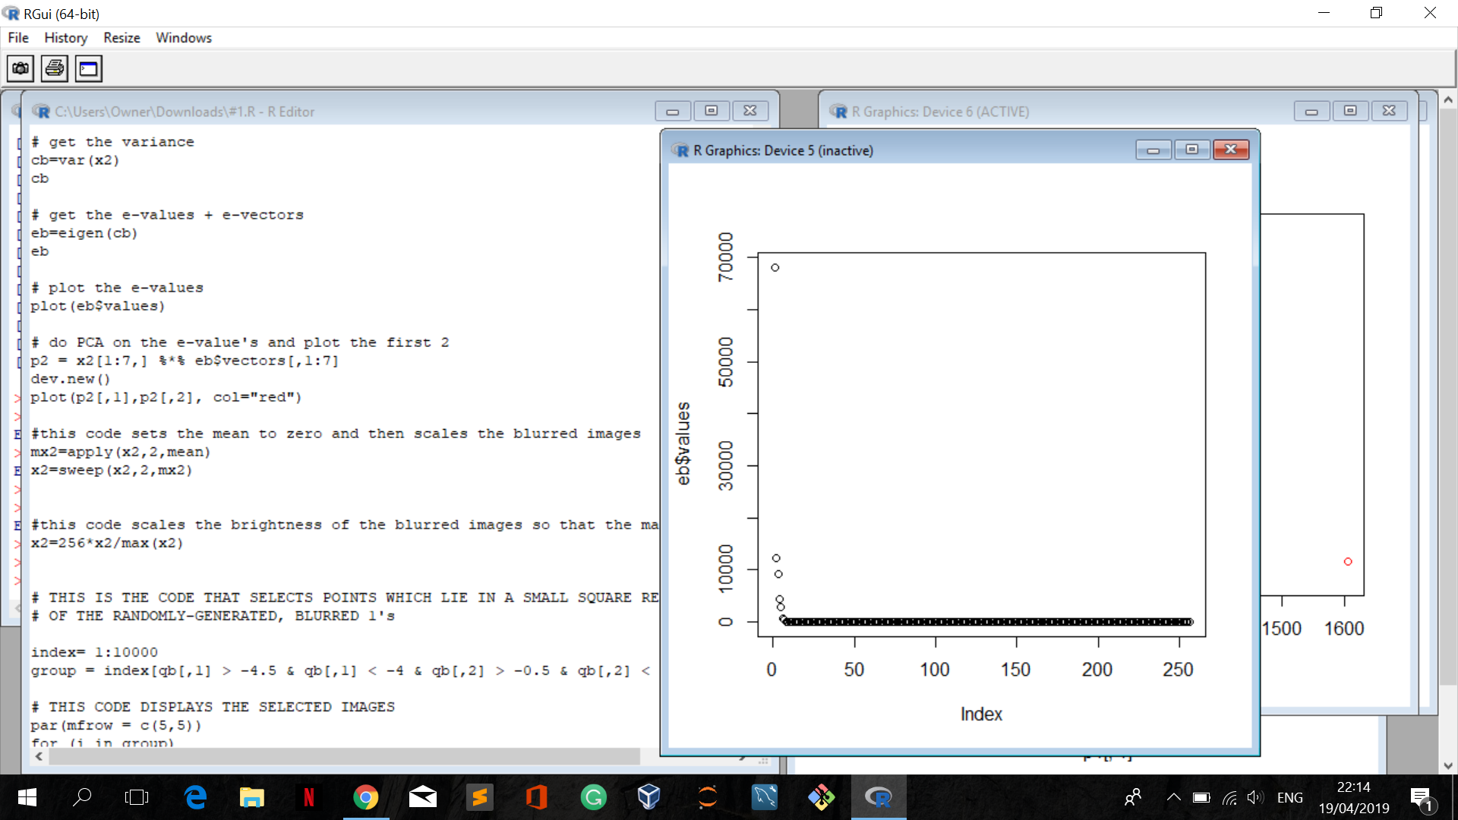

* From looking at the diagram, I can see that only 7 of these eigenvalues are non zero so I decided to pursue using only these first 7 eigenvalues.
* I then projected the blurred images onto these 7 most important eigenvectors with the code below.

*#this code sets the mean to zero and then scales the blurred images*

*mx2 = apply(x2, 2, mean)*

*x2 = sweep(x2, 2, mx2)*

*#this code scales the brightness of the blurred images so that the max is 256*

*x2 = 256 * x2 / max(x2)*

*#project onto the eigenvectors*

*p2 = x2 %*% eb$vectors[,1:7]*

* I then plotted these points with respect to the first 2 eigenvectors using the following lines:

*dev.new()*

*plot(p2[,1], p2[,2], col = "red")*

* The diagram of this plot is below.

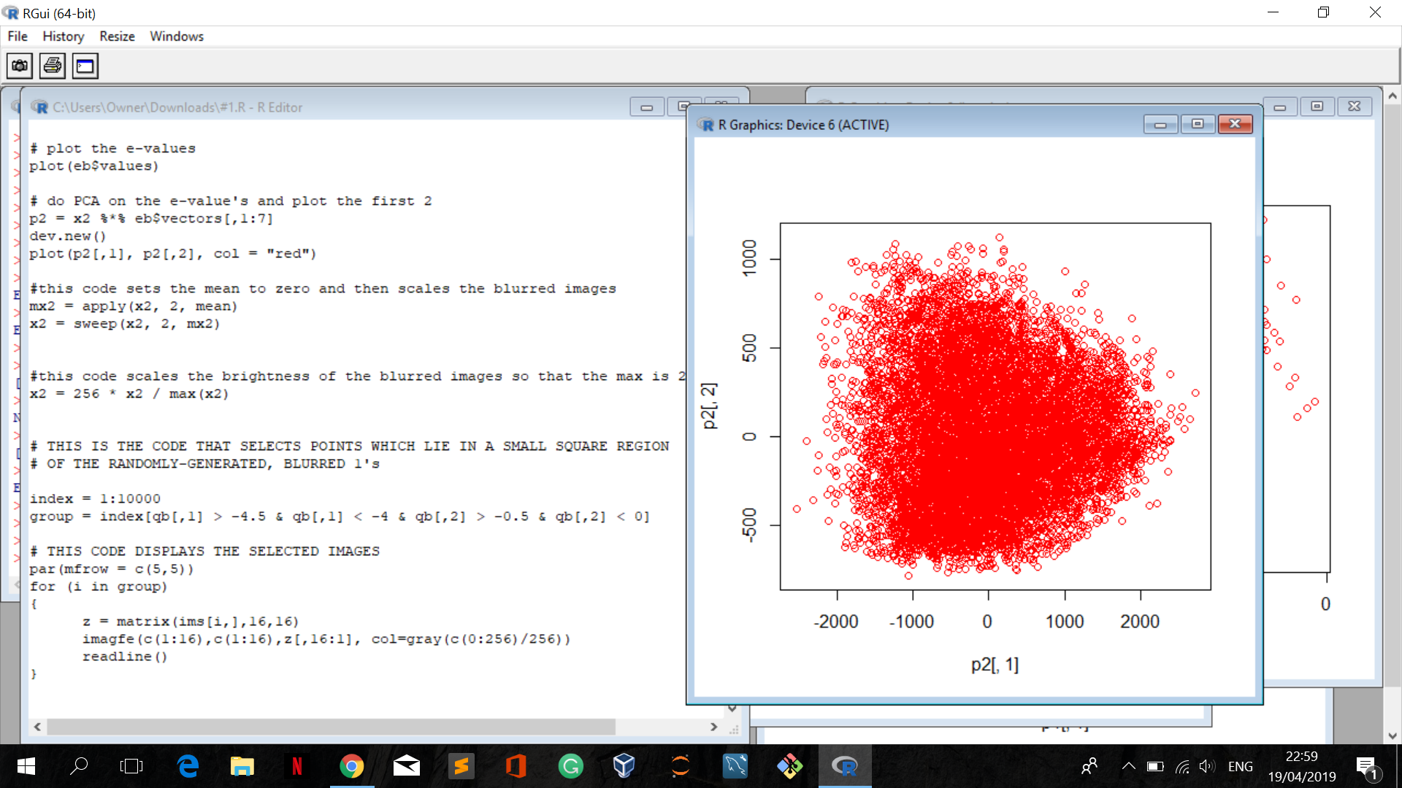

**Part 4 -** Select a small region of this 2D space.

* In my plot, the limits that Alistair had for selecting the region of the square did not contain any points.
* In order to find better limits on the region of this square, I plotted “p2” with respect to the first 2 eigenvectors and then limited the x and y axes until I had a sufficient number of points contained in the square.
* I plotted using the following code*.*

*plot(p2[,1], p2[,2], xlim= c(-50,50), ylim = c(-49,50))*

* Then to actually select a small region of the full 2D space I used the following code.

*index = 1:10000*

*group = index[p2[ ,1] > -50 & p2[ ,1] < 50 & p2[ ,2] > -49 & p2[ ,2] < 50]*

**Part 5 -** Find how many images lie in this square. Adjust the size of the square until you get about 100 images. Display the original unblurred images on your screen.

* To count the number of points/images in this region, I used the following:

*length(group)*

* This told me that this region contained exactly 30 points.
* Using the code from Part 4, I was able to adjust the region so that it contained 102 images.
* The constraints to get this region were:

*-75 < x < 75 & -80 < y < 80*

* To display the unblurred versions of the images selected in this small square, I used the following code.

*par(mfrow = c(3, 3))*

*for (i in group)*

*{*

*z = matrix(ims[i, ], 16, 16)*

*image(c(1:16), c(1:16), z[ ,16:1], col = gray(c(0:256) / 256))*

*readline()*

*}*

* I felt the best amount of plots per diagram was 3 x 3 as this allowed the images to be sufficiently large to be able to see them properly and also allowed there to be a good amount of images so that they could be properly compared.
* An example of 9 out of the 102 images being plotted together is below.

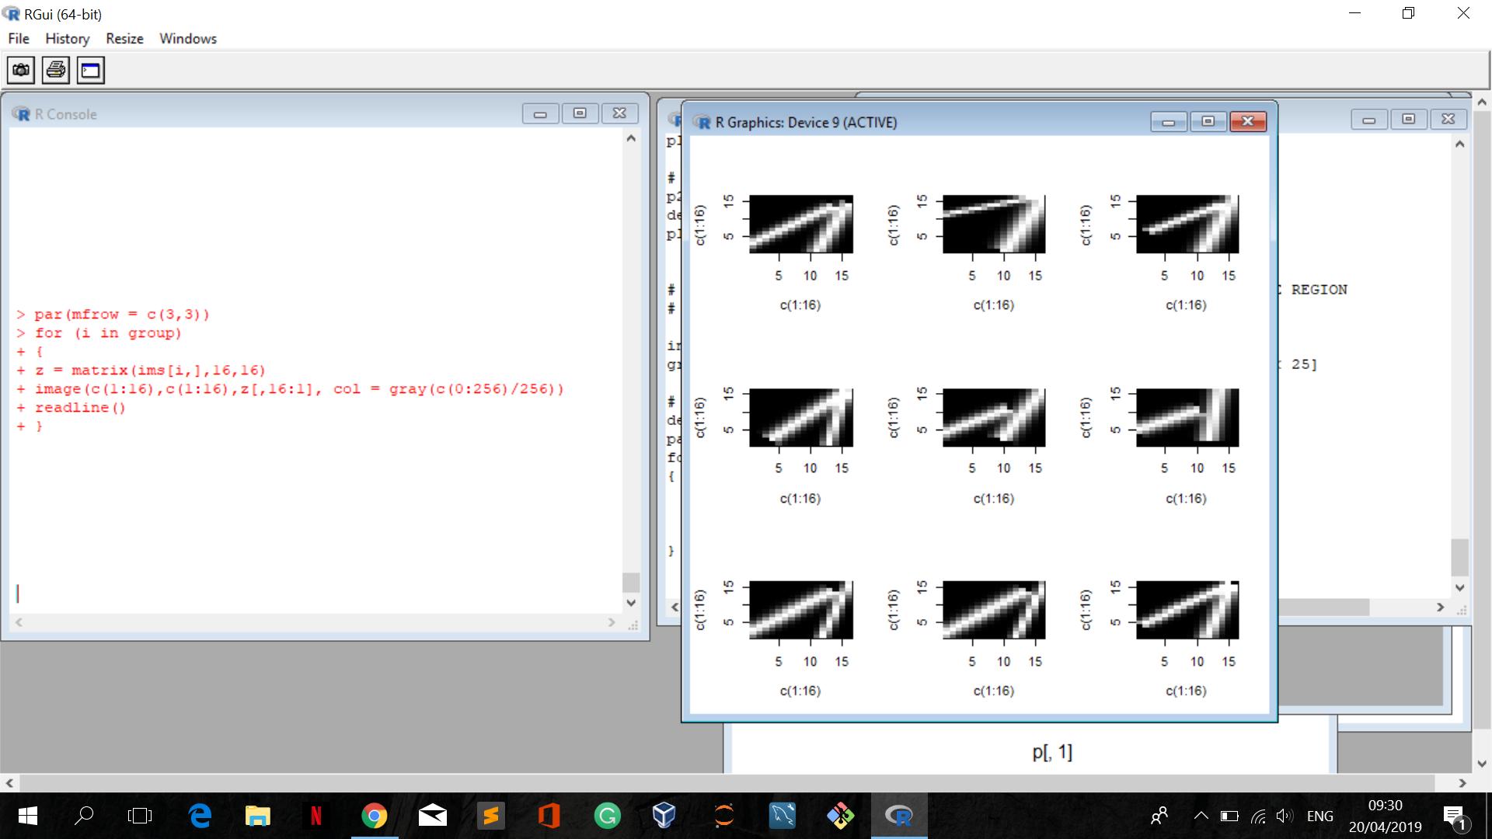

**Part 6 -** Do the images look similar?

* From looking at various images, I noticed that the images look very similar.
* From just the above example of the 9 images, we can see that:
  + The line thickness’ all seem to be about the same size bar the top line in the 2nd image.
  + All images bar the 5th and 6th image have both starting points in the top right corner.
  + The angles of the second line seem to be quite vertical but with a slight angle to the left as they go from top to bottom.
  + The angle of the first line also doesn’t seem to vary too much except for the 2nd image.
  + The length of both stokes also doesn’t vary too much when compared with the others bar the 1st stroke in the 5th and 6th image.
* Overall both of the strokes look similar, they have similar angles and thickness and the starting points also are around the same point when compared to their respective strokes in the other images.

**Part 7 -** Find the parameter vectors for these images. Find the mean and standard deviation for each parameter.

* To first find the parameter vectors for these images, I used the following code:

*vec = matrix(0,10,1)*

*for (i in group)*

*{*

*vec = cbind(vec, params[i,]))*

*}*

* I then found the mean and standard deviations for each parameter.

*# get rid of the first row of all zeros*

*vec = vec[ ,2:102]*

*# find the mean for each value in the parameter vector (across rows)*

*mvec = apply(vec, 1, mean)*

*mvec*

*#get the standard deviation for each value in the param vector (across rows)*

*sdvec = apply(vec, 1, sd)*

*sdvec*

**Part 8 -** Select other small square regions in other parts of the distribution. Find the images in each square. Display them on your screen.

* This part took quite some time with figuring out the boundaries for each of the squares, plotting these squares, finding the images within each square and then displaying these images.
* I figured from looking at the plot that the bulk of the data from my distribution was contained in between:

*-2000 < x < 2100 & -750 < y < 1000*

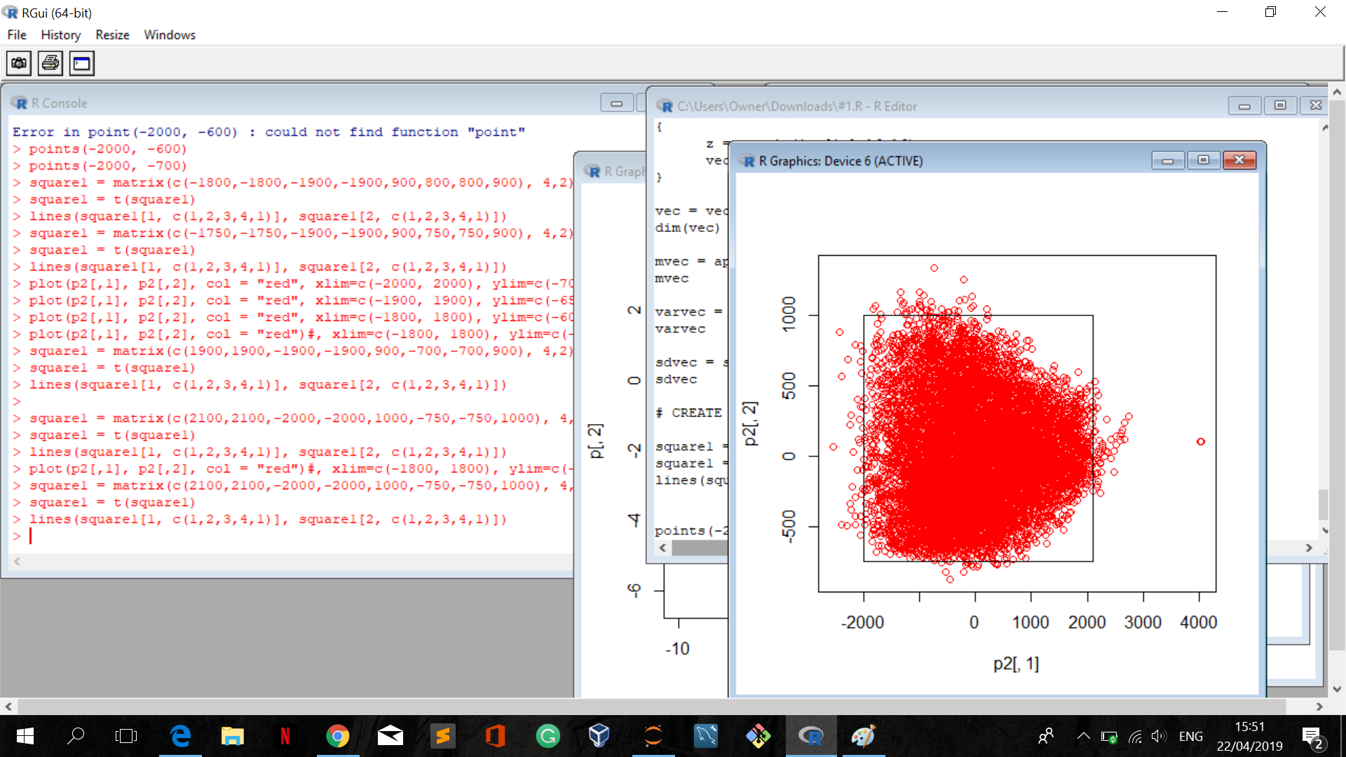

* The above square illustrates that the majority of the data is within these boundaries
* It was plotted using the code below.

*param_square = matrix(c(2100,2100,-2000,-2000,1000,-750,-750,1000), 4,2)*

*param_square = t(param_square)*

*lines(param_square[1, c(1,2,3,4,1)], param_square[2, c(1,2,3,4,1)])*

* Then to create a 5x5 grid of squares evenly spaced across the distribution, I first got the middle square using the midpoint of the established x and y ranges and then used this to get boundaries for the other squares.
* I decided to use 150 x 150 squares.
* The following diagram is an illustration of the location of these squares over the distribution.

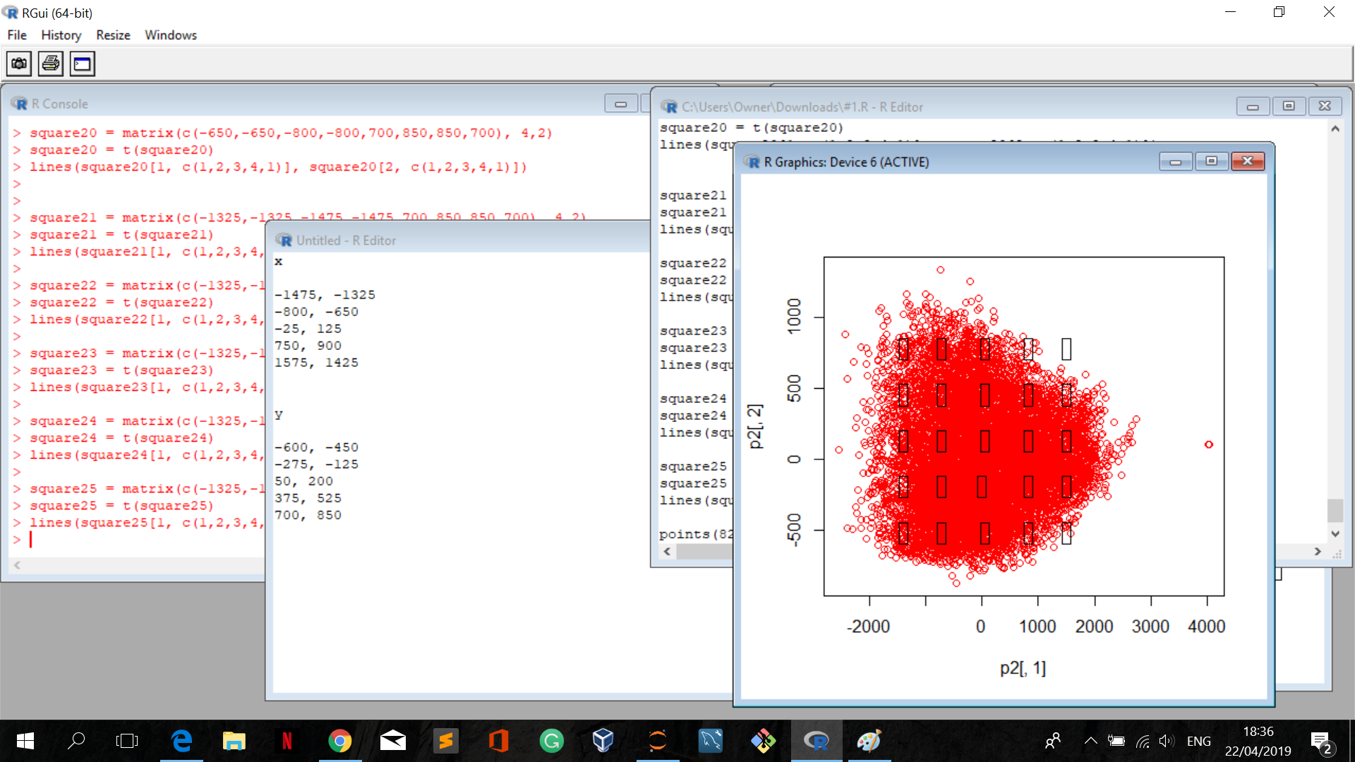

* They don’t look like squares due to the different scales of the x and y axes.
* The code I used to create these squares and containing their boundaries is below.

*square1 = matrix(c(125,125,-25,-25,-600,-450,-450,-600), 4,2)*

*square1 = t(square1)*

*lines(square1[1, c(1,2,3,4,1)], square1[2, c(1,2,3,4,1)])*

*square2 = matrix(c(125,125,-25,-25,-275,-125,-125,-275), 4,2)*

*square2 = t(square2)*

*lines(square[2, c(1,2,3,4,1)], square2[2, c(1,2,3,4,1)])*

*square3 = matrix(c(125,125,-25,-25,200,50,50,200), 4,2)*

*square3 = t(square3)*

*lines(square3[1, c(1,2,3,4,1)], square3[2, c(1,2,3,4,1)])*

*square4 = matrix(c(125,125,-25,-25,525,375,375,525), 4,2)*

*square4 = t(square4)*

*lines(square4[1, c(1,2,3,4,1)], square4[2, c(1,2,3,4,1)])*

*square5 = matrix(c(125,125,-25,-25,850,700,700,850), 4,2)*

*square5 = t(square5)*

*lines(square5[1, c(1,2,3,4,1)], square5[2, c(1,2,3,4,1)])*

*square6 = matrix(c(1575,1575,1425,1425,850,700,700,850), 4,2)*

*square6 = t(square6)*

*lines(square6[1, c(1,2,3,4,1)], square6[2, c(1,2,3,4,1)])*

*square7 = matrix(c(1575,1575,1425,1425,525,375,375,525), 4,2)*

*square7 = t(square7)*

*lines(square7[1, c(1,2,3,4,1)], square7[2, c(1,2,3,4,1)])*

*square8 = matrix(c(1575,1575,1425,1425,200,50,50,200), 4,2)*

*square8 = t(square8)*

*lines(square8[1, c(1,2,3,4,1)], square8[2, c(1,2,3,4,1)])*

*square9 = matrix(c(1575,1575,1425,1425,-125,-275,-275,-125), 4,2)*

*square9 = t(square9)*

*lines(square9[1, c(1,2,3,4,1)], square9[2, c(1,2,3,4,1)])*

*square10 = matrix(c(1575,1575,1425,1425,-600,-450,-450,-600), 4,2)*

*square10 = t(square10)*

*lines(square10[1, c(1,2,3,4,1)], square10[2, c(1,2,3,4,1)])*

*square11 = matrix(c(900,900,750,750,850,700,700,850), 4,2)*

*square11 = t(square11)*

*lines(square11[1, c(1,2,3,4,1)], square11[2, c(1,2,3,4,1)])*

*square12 = matrix(c(900,900,750,750,525,375,375,525), 4,2)*

*square12 = t(square12)*

*lines(square12[1, c(1,2,3,4,1)], square12[2, c(1,2,3,4,1)])*

*square13 = matrix(c(900,900,750,750,200,50,50,200), 4,2)*

*square13 = t(square13)*

*lines(square13[1, c(1,2,3,4,1)], square13[2, c(1,2,3,4,1)])*

*square14 = matrix(c(900,900,750,750,-600,-450,-450,-600), 4,2)*

*square14 = t(square14)*

*lines(square14[1, c(1,2,3,4,1)], square14[2, c(1,2,3,4,1)])*

*square15 = matrix(c(900,900,750,750,-275,-125,-125,-275), 4,2)*

*square15 = t(square15)*

*lines(square15[1, c(1,2,3,4,1)], square15[2, c(1,2,3,4,1)])*

*square16 = matrix(c(-650,-650,-800,-800,-600,-450,-450,-600), 4,2)*

*square16 = t(square16)*

*lines(square16[1, c(1,2,3,4,1)], square16[2, c(1,2,3,4,1)])*

*square17 = matrix(c(-650,-650,-800,-800,-275,-125,-125,-275), 4,2)*

*square17 = t(square17)*

*lines(square17[1, c(1,2,3,4,1)], square17[2, c(1,2,3,4,1)])*

*square18 = matrix(c(-650,-650,-800,-800,50,200,200,50), 4,2)*

*square18 = t(square18)*

*lines(square18[1, c(1,2,3,4,1)], square18[2, c(1,2,3,4,1)])*

*square19 = matrix(c(-650,-650,-800,-800,375,525,525,375), 4,2)*

*square19 = t(square19)*

*lines(square19[1, c(1,2,3,4,1)], square19[2, c(1,2,3,4,1)])*

*square20 = matrix(c(-650,-650,-800,-800,700,850,850,700), 4,2)*

*square20 = t(square20)*

*lines(square20[1, c(1,2,3,4,1)], square20[2, c(1,2,3,4,1)])*

*square21 = matrix(c(-1325,-1325,-1475,-1475,700,850,850,700), 4,2)*

*square21 = t(square21)*

*lines(square21[1, c(1,2,3,4,1)], square21[2, c(1,2,3,4,1)])*

*square22 = matrix(c(-1325,-1325,-1475,-1475,375,525,525,375), 4,2)*

*square22 = t(square22)*

*lines(square22[1, c(1,2,3,4,1)], square22[2, c(1,2,3,4,1)])*

*square23 = matrix(c(-1325,-1325,-1475,-1475,50,200,200,50), 4,2)*

*square23 = t(square23)*

*lines(square23[1, c(1,2,3,4,1)], square23[2, c(1,2,3,4,1)])*

*square24 = matrix(c(-1325,-1325,-1475,-1475,-275,-125,-125,-275), 4,2)*

*square24 = t(square24)*

*lines(square24[1, c(1,2,3,4,1)], square24[2, c(1,2,3,4,1)])*

*square25 = matrix(c(-1325,-1325,-1475,-1475,-600,-450,-450,-600), 4,2)*

*square25 = t(square25)*

*lines(square25[1, c(1,2,3,4,1)], square25[2, c(1,2,3,4,1)])*

* I then created the groups of images contained within these squares using the following code:

*group1 = index[p2[,1] > -25 & p2[,1] < 125 & p2[,2] > -450 & p2[,2] < 600]*

*group2 = index[p2[,1] > -275 & p2[,1] < -25 & p2[,2] > -275 & p2[,2] < -125]*

*group3 = index[p2[,1] > -25 & p2[,1] < 125 & p2[,2] > 50 & p2[,2] < 200]*

*group4 = index[p2[,1] > -25 & p2[,1] < 125 & p2[,2] > 375 & p2[,2] < 525]*

*group5 = index[p2[,1] > -25 & p2[,1] < 125 & p2[,2] > 700 & p2[,2] < 850]*

*group6 = index[p2[,1] > 1425 & p2[,1] < 1575 & p2[,2] > 700 & p2[,2] < 850]*

*group7 = index[p2[,1] > 1425 & p2[,1] < 1575 & p2[,2] > 375 & p2[,2] < 525]*

*group8 = index[p2[,1] > 1425 & p2[,1] < 1575 & p2[,2] > 50 & p2[,2] < 200]*

*group9 = index[p2[,1] > 1425 & p2[,1] < 1575 & p2[,2] > -275 & p2[,2] < -125]*

*group10 = index[p2[,1] > 1425 & p2[,1] < 1575 & p2[,2] > -600 & p2[,2] < -450]*

*group11 = index[p2[,1] > 750 & p2[,1] < 900 & p2[,2] > 700 & p2[,2] < 850]*

*group12 = index[p2[,1] > 750 & p2[,1] < 900 & p2[,2] > 375 & p2[,2] < 525]*

*group13 = index[p2[,1] > 750 & p2[,1] < 900 & p2[,2] > 50 & p2[,2] < 200]*

*group14 = index[p2[,1] > 750 & p2[,1] < 900 & p2[,2] > -600 & p2[,2] < -450]*

*group15 = index[p2[,1] > 750 & p2[,1] < 900 & p2[,2] > -275 & p2[,2] < -125]*

*group16 = index[p2[,1] > -800 & p2[,1] < -650 & p2[,2] > -600 & p2[,2] < -450]*

*group17 = index[p2[,1] > -800 & p2[,1] < -650 & p2[,2] > -275 & p2[,2] < -125]*

*group18 = index[p2[,1] > -800 & p2[,1] < -650 & p2[,2] > 50 & p2[,2] < 200]*

*group19 = index[p2[,1] > -800 & p2[,1] < -650 & p2[,2] > 375 & p2[,2] < 525]*

*group20 = index[p2[,1] > -800 & p2[,1] < -650 & p2[,2] > 700 & p2[,2] < 850]*

*group21 = index[p2[,1] > -1475 & p2[,1] < -1325 & p2[,2] > 700 & p2[,2] < 850]*

*group22 = index[p2[,1] > -1475 & p2[,1] < -1325 & p2[,2] > 375 & p2[,2] < 525]*

*group23 = index[p2[,1] > -1475 & p2[,1] < -1325 & p2[,2] > 50 & p2[,2] < 200]*

*group24 = index[p2[,1] > -1475 & p2[,1] < -1325 & p2[,2] > -275 & p2[,2] < -125]*

*group25 = index[p2[,1] > -1475 & p2[,1] < -1325 & p2[,2] > -600 & p2[,2] < -450]*

* Then to visualise these images I used the following code replacing “group” with the respective group name.

*dev.new()*

*par(mfrow = c(3,3))*

*for (i in group)*

*{*

*z = matrix(ims[i,],16,16)*

*image(c(1:16),c(1:16),z[,16:1], col = gray(c(0:256)/256))*

*readline()*

*}*

* I could have pasted these images int his report but i deemed that too time consuming and didn’t think it would add anything to this part of the report.

**Part 9 -** Are there any trends across the distribution?

* In order to see the trends, I wanted to explore the differences between images contained in particular squares.
* I first looked at the middle 5 squares going from the top to the bottom of the distribution.
* A selection of images from these 5 squares is below.
* 9 images from the top-middle square in the distribution.

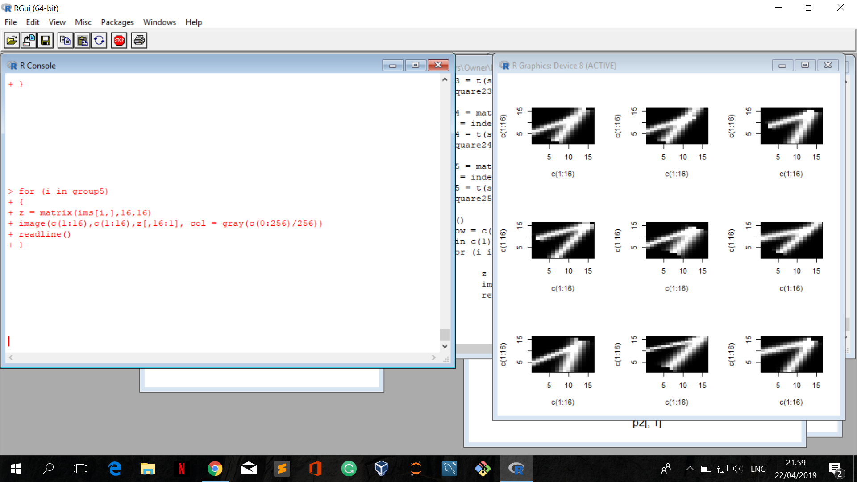

* 9 images from the upper middle square in the distribution.

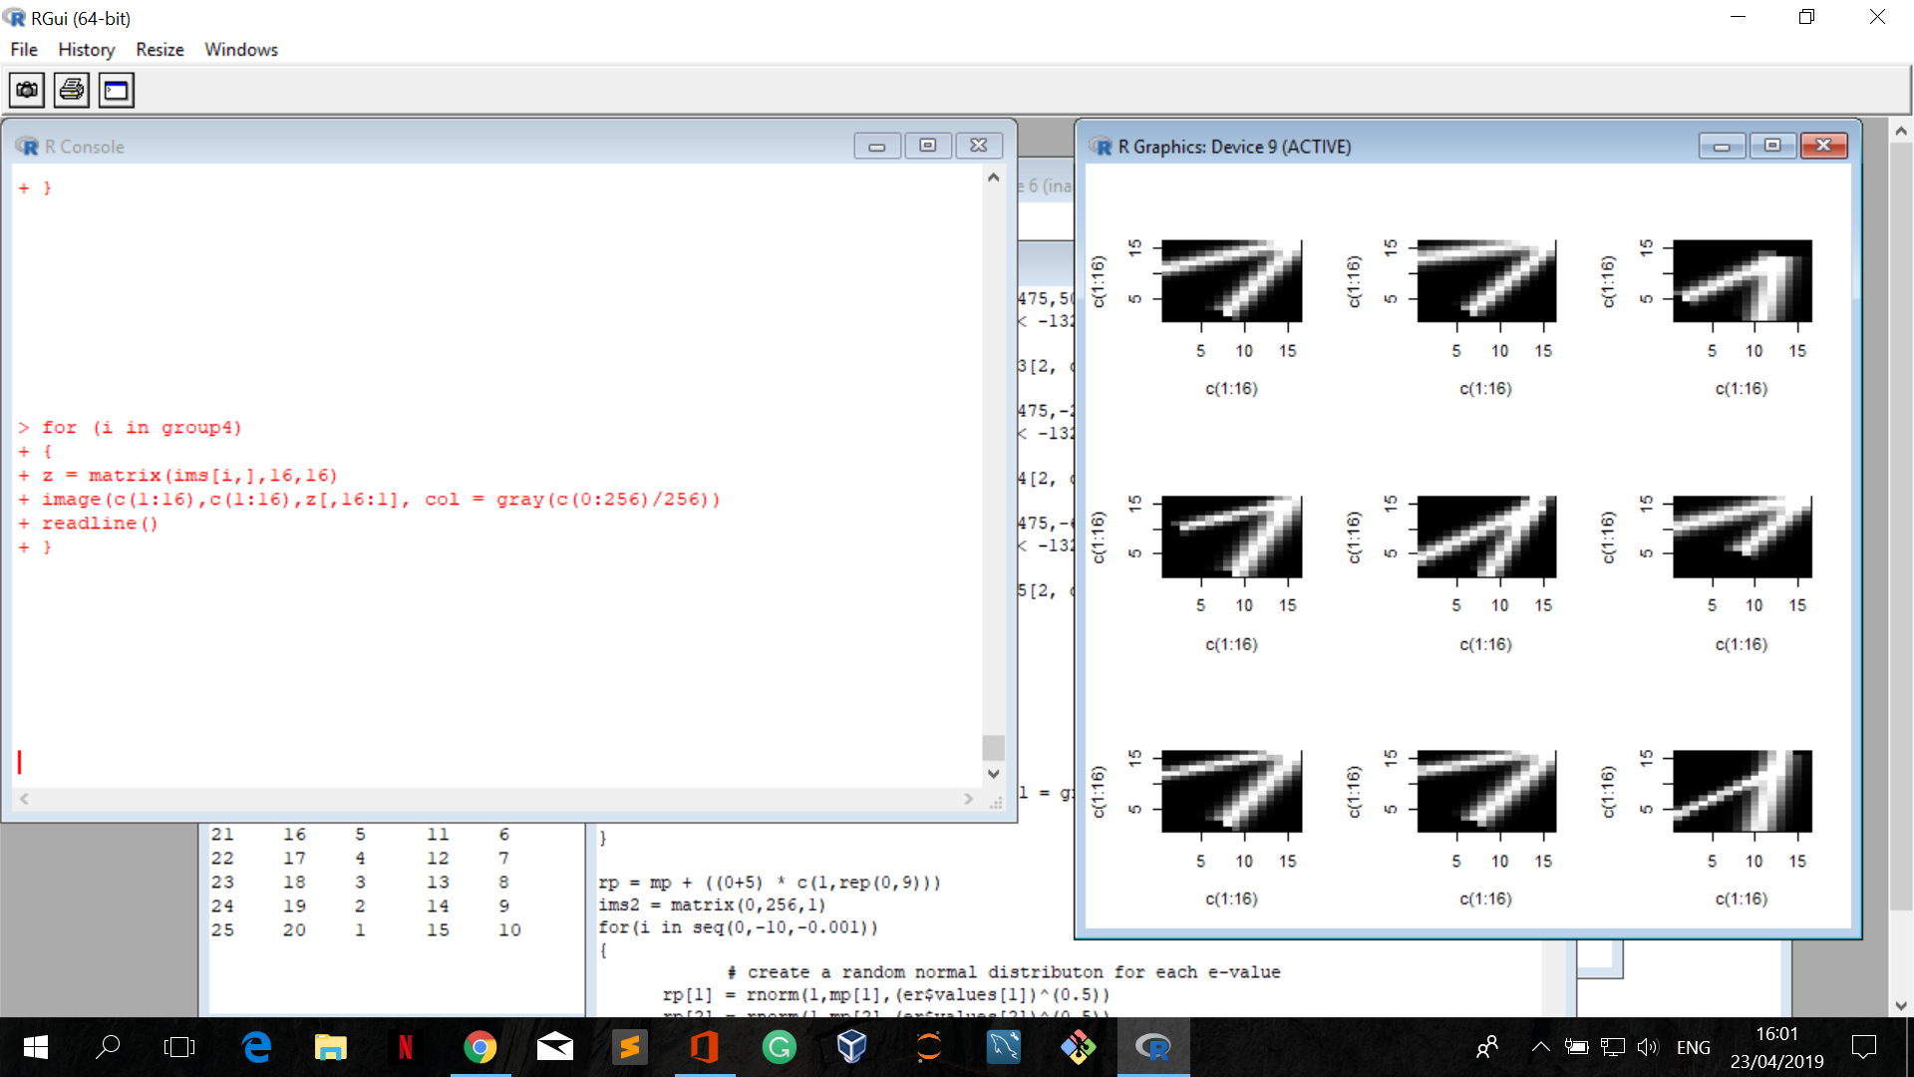

* 9 images from the center middle square in the distribution.

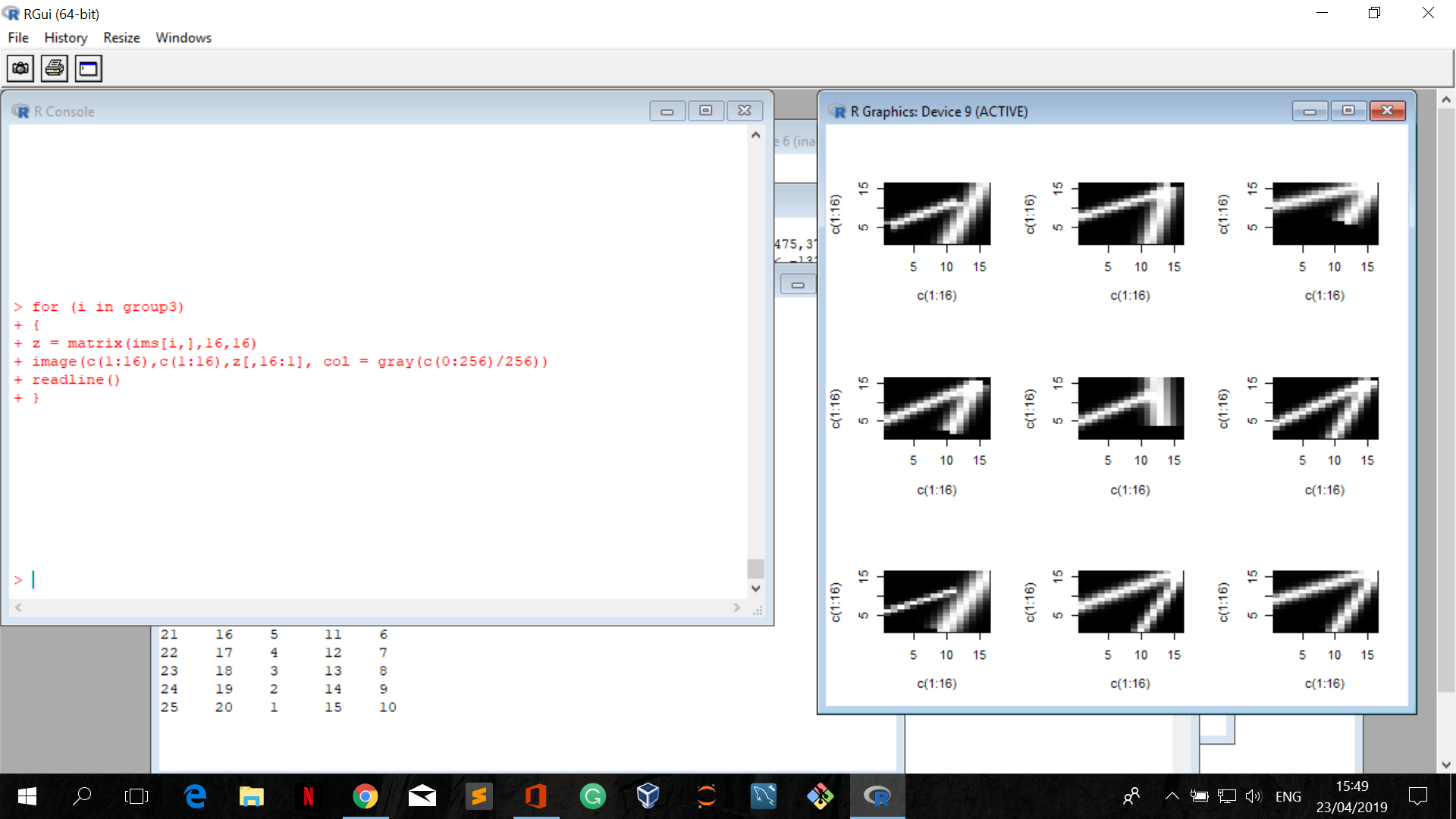

* 9 images from the lower middle square in the distribution.

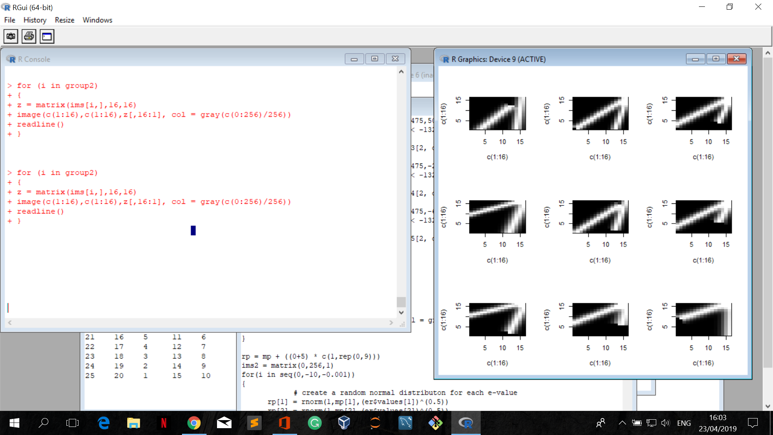

* 9 images from the bottom middle square in the distribution.

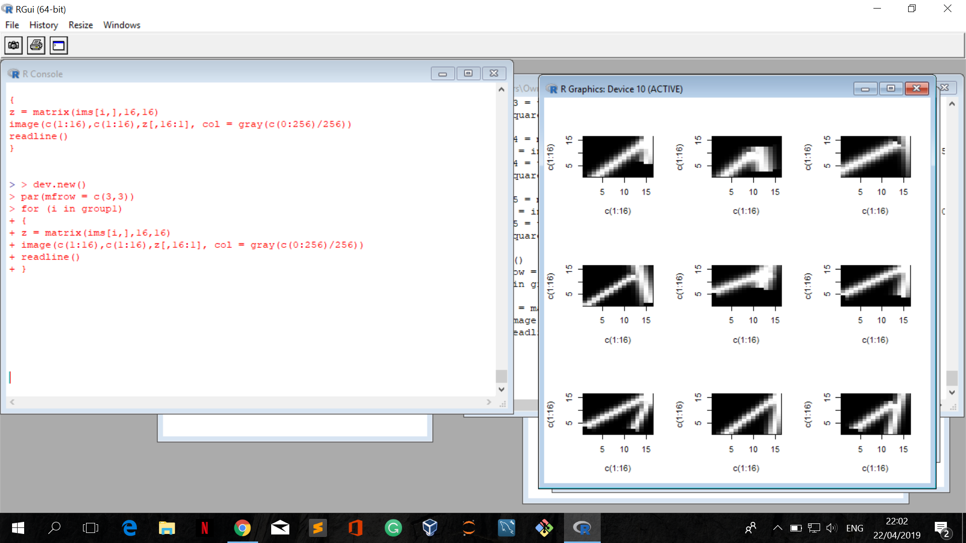

* From comparing these images, a trend I see is that as we go down the distribution, the angle of both strokes increases and it seems as if the images is being rotated to the right.
* The second line’s angle becomes more vertical and the first line’s angle becomes less horizontal.
* At the top, the first line seems like it’s just off being a horizontal line and the second line seems about 30 degrees.
* At the bottom, the second line seems like it’s just off being a vertical line and the fist line seems about 60 degrees.
* I then looked at the middle 5 squares going from the left to the right of the distribution.
* A selection of images from these 5 squares are displayed below.
* 9 images from the left-middle square in the distribution.

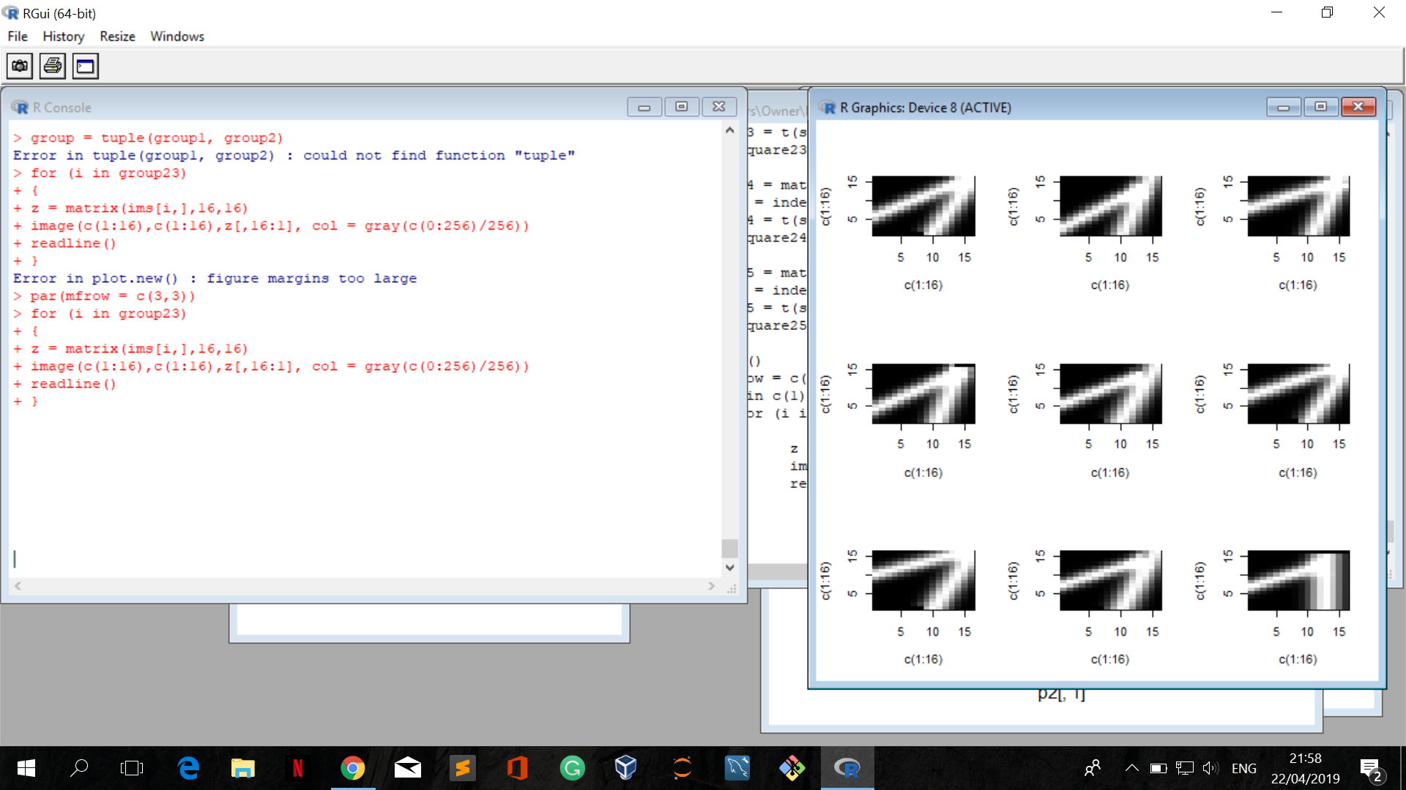

* 9 images from the center left square in the distribution.

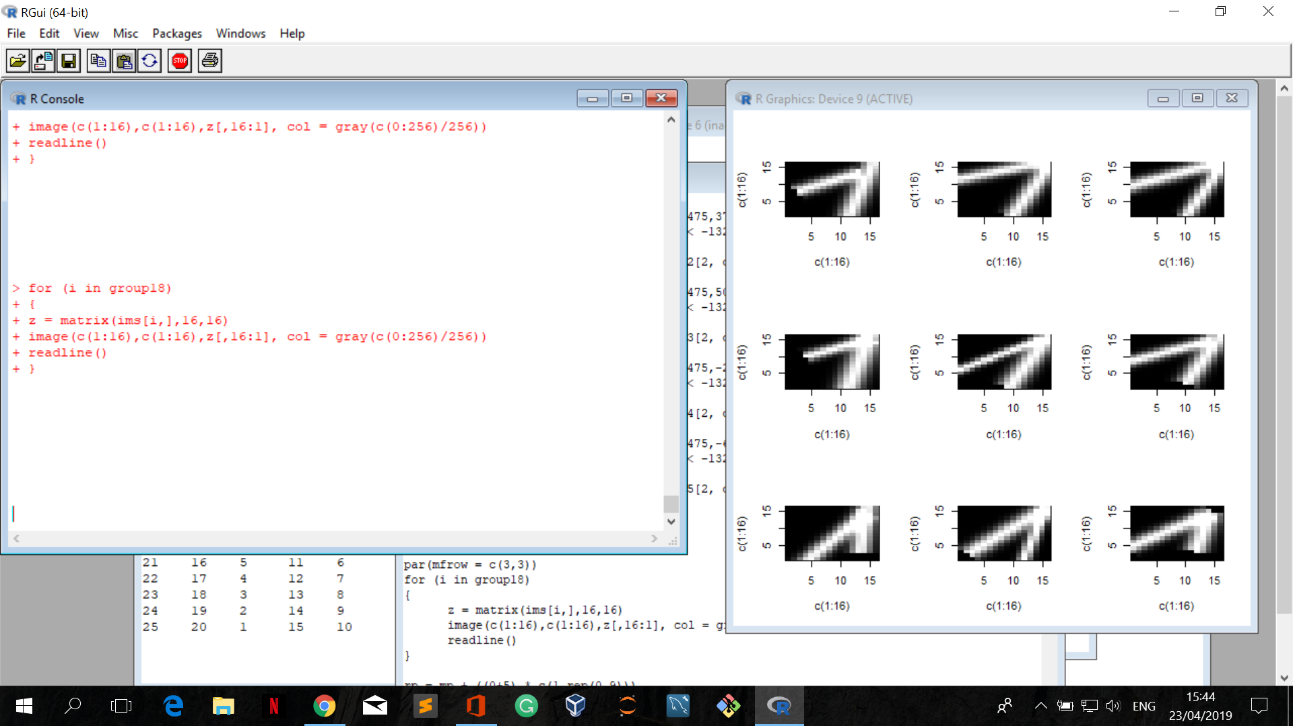

* 9 images from the middle square in the distribution.



* 9 images from the middle center-right square in the distribution.

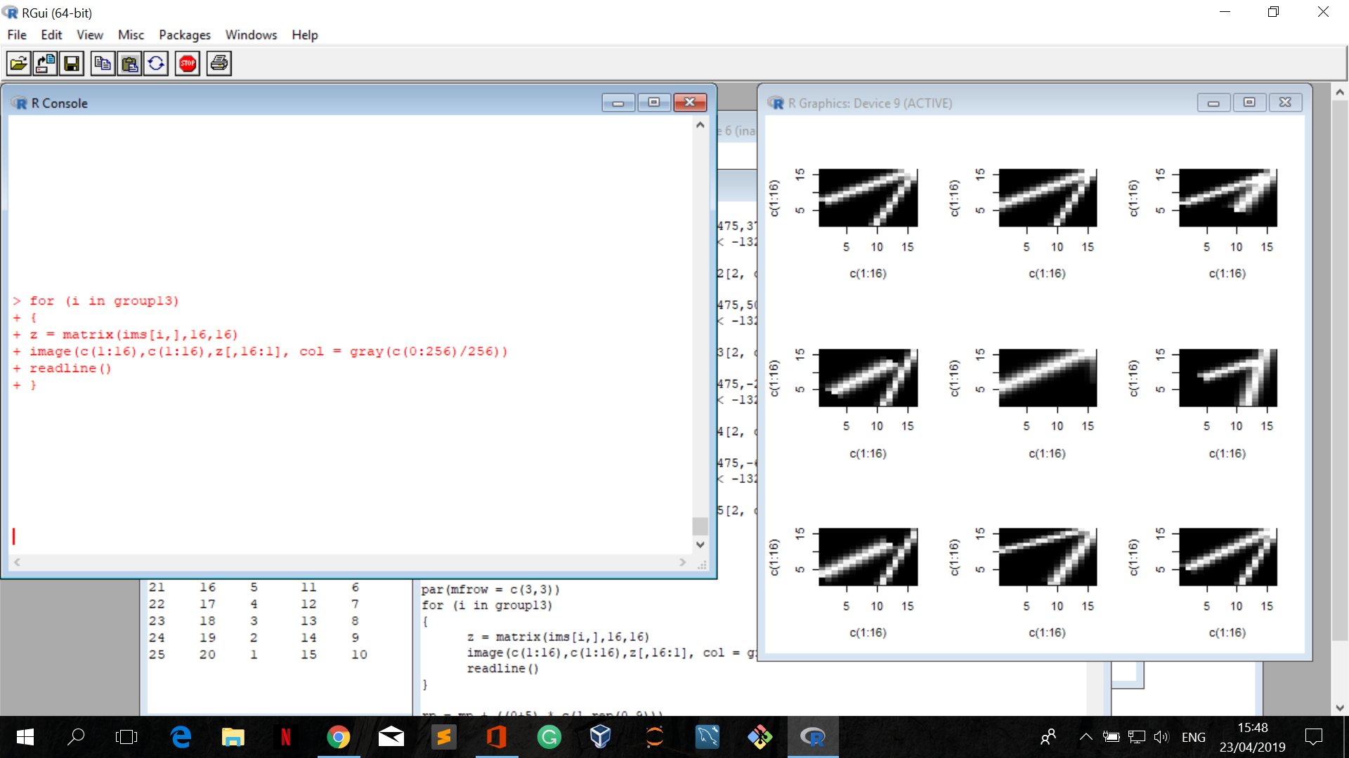

* 9 images from the middle right square in the distribution.

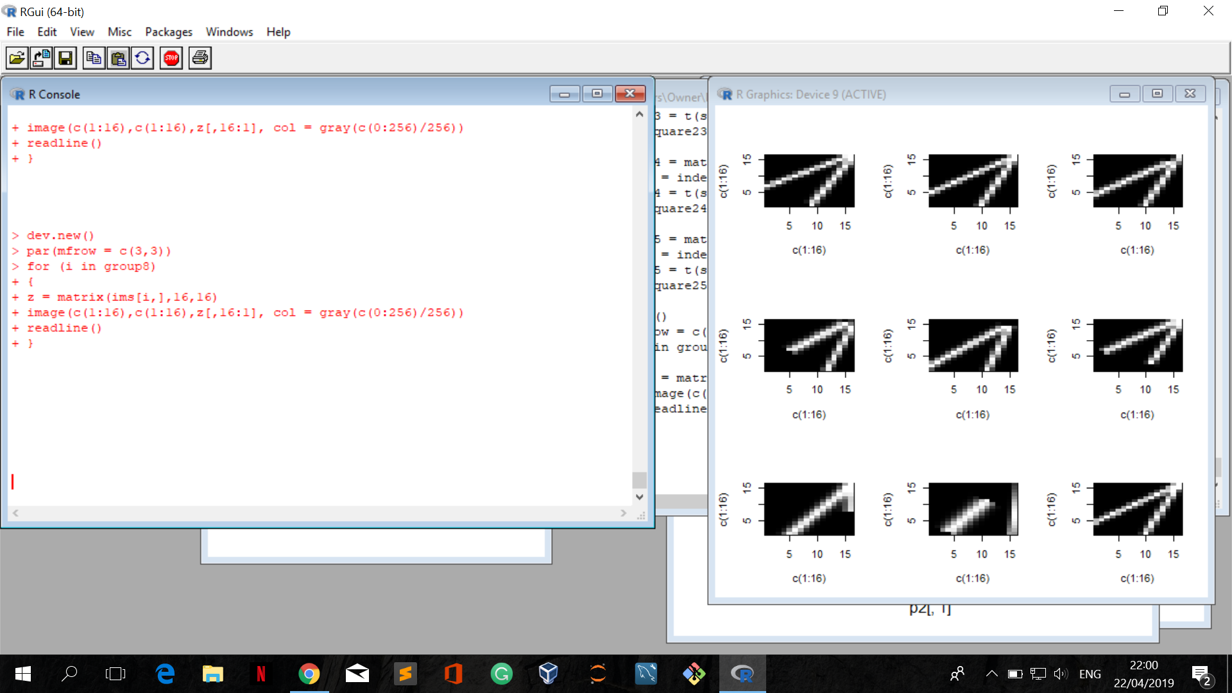

* From looking at these images, we can see that the thickness of the lines changes as we move across the distribution.
* At the left of the distribution, we can see that the lines widths are quite thick.
* At the right of the distribution, we can see that the lines widths are quite skinny.
* As we go from left to right, the lines get less thick.
* The angles, starting points and lengths of the strokes do not change much during this transition.

**Part 10 -** Generate another set of 10000 random '1's. Project these images onto the same eigenvectors as the first set.

* I used the following code to create another set of 10,000 random 1’s.

*rp = mp + ((0+5) * c(1,rep(0,9)))*

*ims2 = matrix(0,256,1)*

*params2 = matrix(0,10,1)*

*for(i in seq(0,-10,-0.001))*

*{*

*# create a random normal distribution for each e-value*

*rp[1] = rnorm(1,mp[1],(er$values[1])^(0.5))*

*rp[2] = rnorm(1,mp[2],(er$values[2])^(0.5))*

*rp[3] = rnorm(1,mp[3],(er$values[3])^(0.5))*

*rp[4] = rnorm(1,mp[4],(er$values[4])^(0.5))*

*rp[5] = rnorm(1,mp[5],(er$values[5])^(0.5))*

*rp[6] = rnorm(1,mp[6],(er$values[6])^(0.5))*

*rp[7] = rnorm(1,mp[7],(er$values[7])^(0.5))*

*rp[8] = rnorm(1,mp[8],(er$values[8])^(0.5))*

*rp[9] = rnorm(1,mp[9],(er$values[9])^(0.5))*

*rp[10] = rnorm(1,mp[10],(er$values[10])^(0.5))*

*rp3 = rp %*% t(er$vectors[,1:10])*

*rec2 = rp3 * sqrt(resvar)*

*# put constraints on the images*

*rec2[1] = max(min(17, rec2[1]),10) #x1*

*rec2[2] = max(min(17,rec2[1]),10) #y1*

*rec2[3] = min(max(rec2[3], 0.55 * pi), pi* 0.8) #theta1*

*rec2[4] = min(max(10.0,rec2[4]),22.0) #len1*

*rec2[5] = min(max(rec2[5],0.5),5.0) #width1*

*rec2[6] = max(min(17,rec2[6]),10, rec2[1]) #x2*

*rec2[7] = max(min(17,rec2[7]),10, rec2[2]) #y2*

*rec2[8] = min(max(rec2[8],rec2[3]+0.17*pi, 0.8*pi),pi*1.06) #theta2*

*rec2[9] = min(max(10.0,rec2[9]), 18.0) #len2*

*rec2[10] = min(max(rec2[10],0.5),7.0) #width2*

*# plot the strokes*

*s1 = stroke(rec2[1], rec2[2], rec2[3], rec2[4], rec2[5])*

*s2 = stroke(rec2[6], rec2[7], rec2[8], rec2[9], rec2[10])*

*im2 = s1 + s2*

*im2[im2 > 1] = 1*

*# combine the image vectors and feature vectors*

*ims2 = cbind(ims2, matrix(im2[ ,16:1], 256, 1)*

*params2 = cbind(params2, rec2[1:10])*

*}*

* I then projected these 1’s onto the same eigenvectors as the other ones using 2 pieces of code, 1 when they were not blurred and the other when they were blurred.
* The following code is from when they were not blurred:

*# remove first row of all zeros and transpose it*

*ims2 = ims2[,2:10002]*

*ims2 = t(ims2)*

*# project the images onto the eigenvectors*

*g1 = ims %*% eb$vectors[ ,1:7] # 1st generation*

*g2 = ims2 %*% eb$vectors[ ,1:7] # 2nd generation*

*# plot the images in the vector space*

*dev.new()*

*plot(g1[,1], g1[,2], col = "red", xlim=c(-8.5, -1), ylim= c(-3.5, 4))*

*par(new=TRUE)*

*plot(g2[,1], g2[,2], col = "blue", xlim=c(-8.5, -1), ylim= c(-3.5, 4)*

* The result of this projection was the following image.

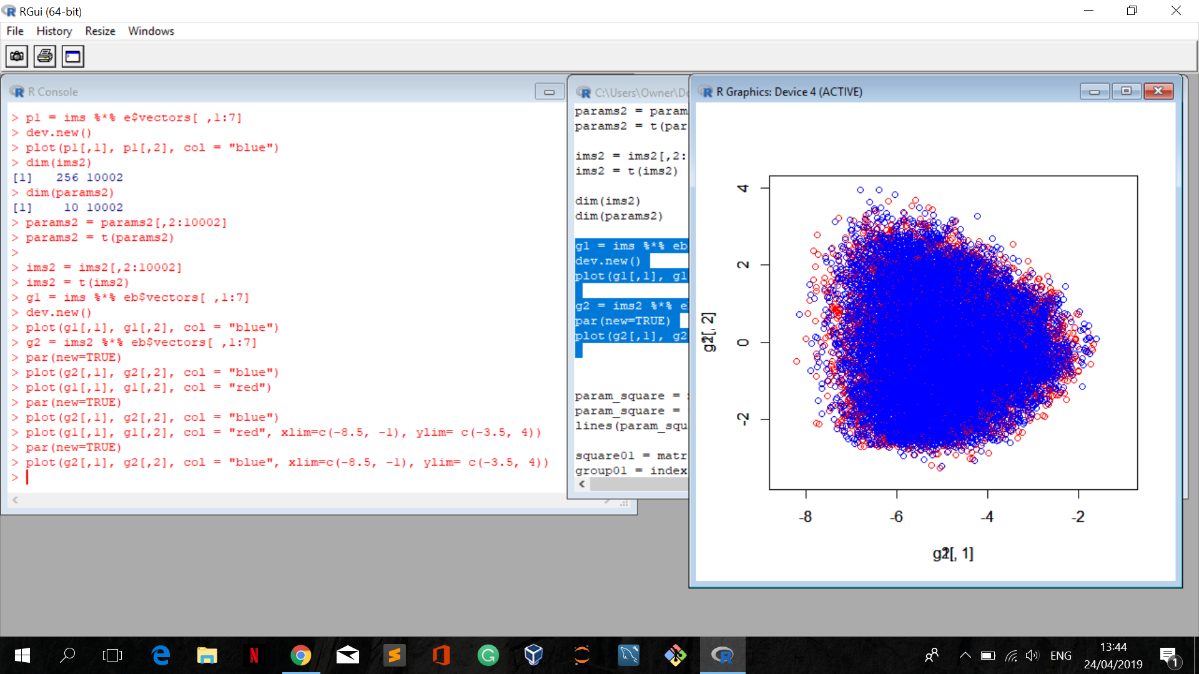

* I then decided to do a blurred projection.
* We already had the blurred images saved in variable “x2” from part 2 (the code is above) so I just had to blur these new images.
* I did this using the following code:

*x3=ims2*

*x4=ims2*

*for(i in c(1:10001))*

*{*

*z = matrix(as.numeric(x4[i,]), 16, 16)*

*ft = fft(z)*

*ft = ft * gau*

*z2=fft(ft,inverse=T)*

*x3[i,] = matrix(abs(z2), 1, 256)*

*}*

*#this code sets the mean to zero and then scales the blurred images*

*mx3 = applyx3, 2, mean)*

*x3 = sweep(x3, 2, mx3)*

*#this code scales the brightness of the blurred images so that the max is 256*

*x3 = 256 * x3 / max(x3)*

*# project these images onto the eigenvectors*

*p3 = x3 %*% eb$vectors[,1:7]*

*p2 = x2 %*% eb$vectors[,1:7]*

*# plot with respect for the first 2 eigenvectors*

*dev.new()*

*plot(p2[,1], p2[,2], col = "red", xlim=c(-2500, 2500), ylim=c(-1000,1200))*

*par(new=TRUE)*

*plot(p3[,1], p3[,2], col = "blue", xlim=c(-2500, 2500), ylim=c(-1000,1200))*

* The result of this projection was the following image.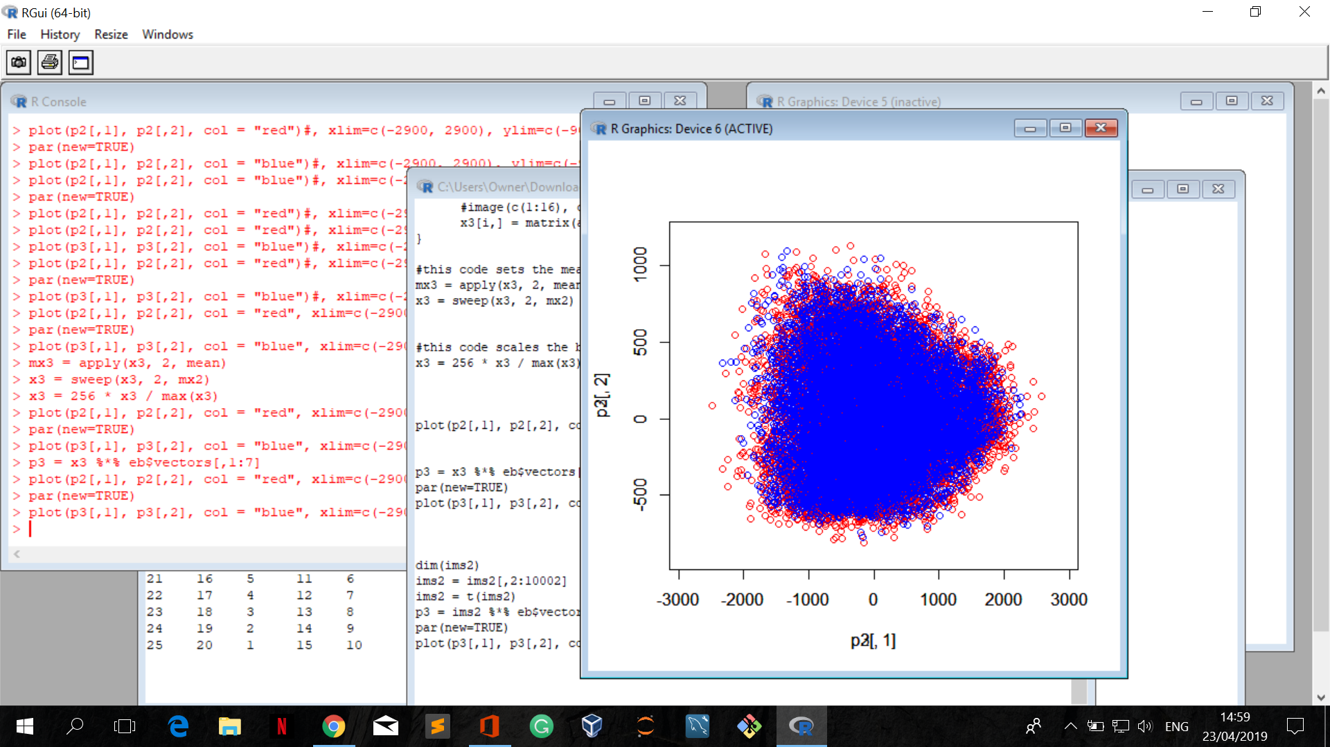

**Part 11 -** For some of the small square regions from step 8, find which of the new set of images fall within these regions. Are they similar to the images from the first set? Do their parameter vectors lie close to the means of the first set?

* When selecting a few of the regions from step 8, I decided to choose 4 random squares randomly from across the distribution out of the 5 x 5 grid when comparing the 2 plots.
* The following are 9 and 8 Images from the bottom left square in both the distribution of the first and second generation of 1’s repectively.

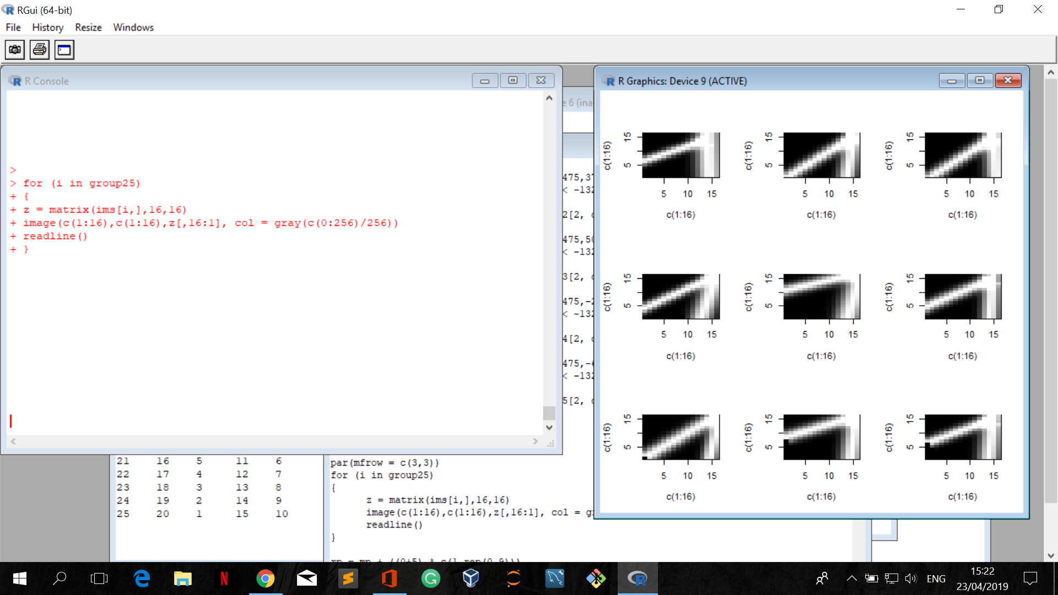←------First generation

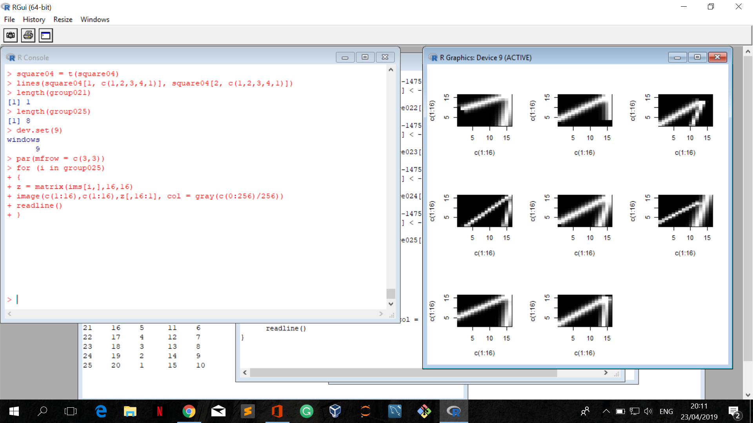 ←------Second generation

* The following are 9 images from the bottom center-right square in both the distribution of the first and second generation of 1’s.

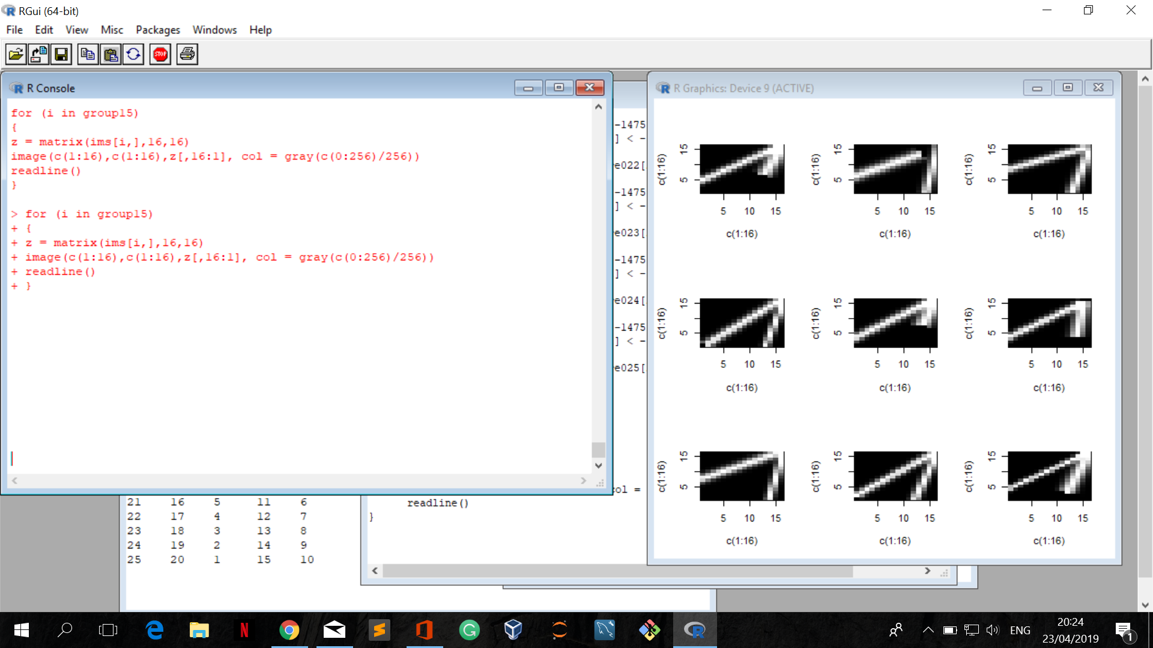←------First generation

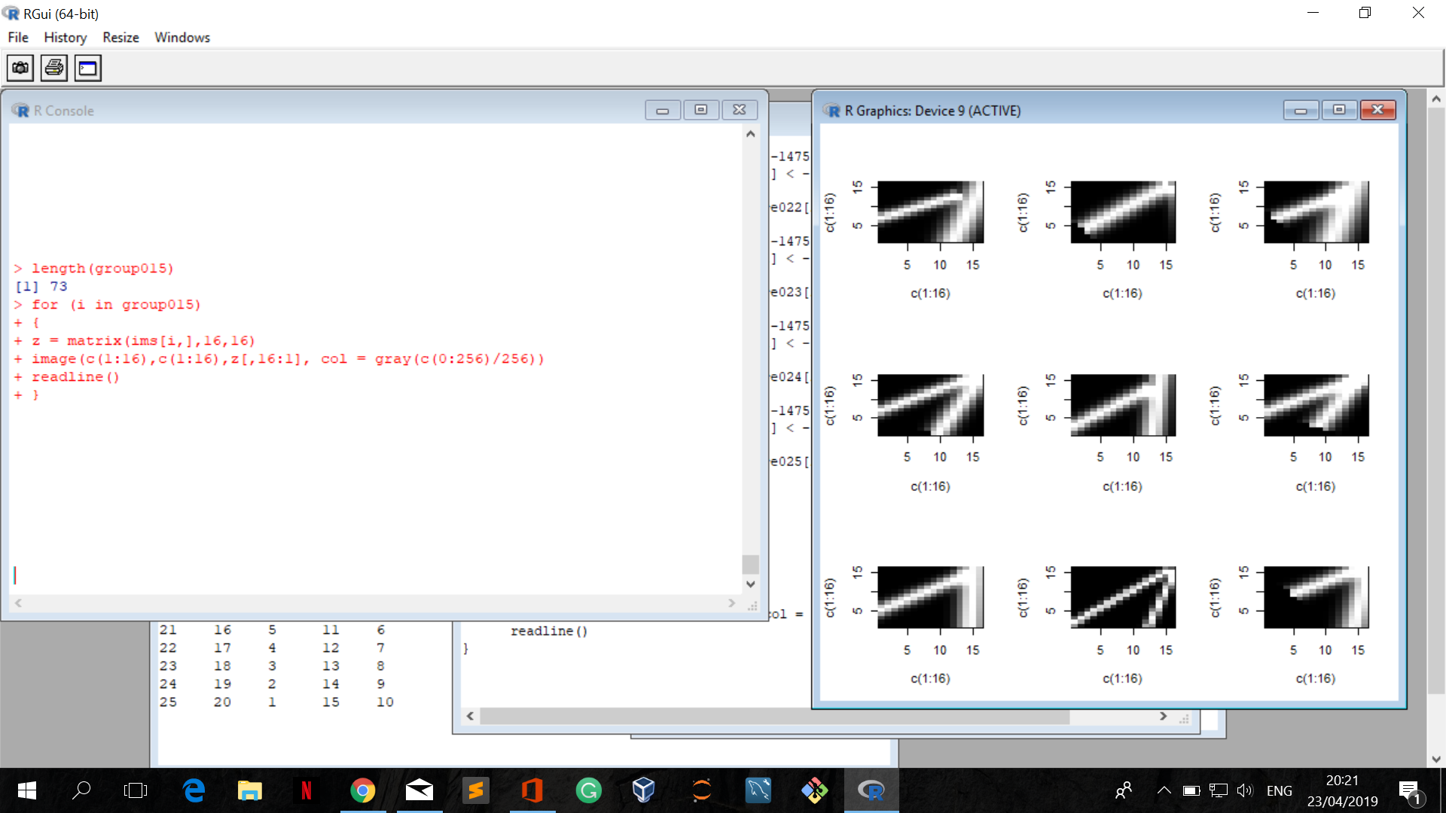←------Second generation

* The following are 9 images from the left upper-center square in both the distribution of the first and second generation of 1’s.

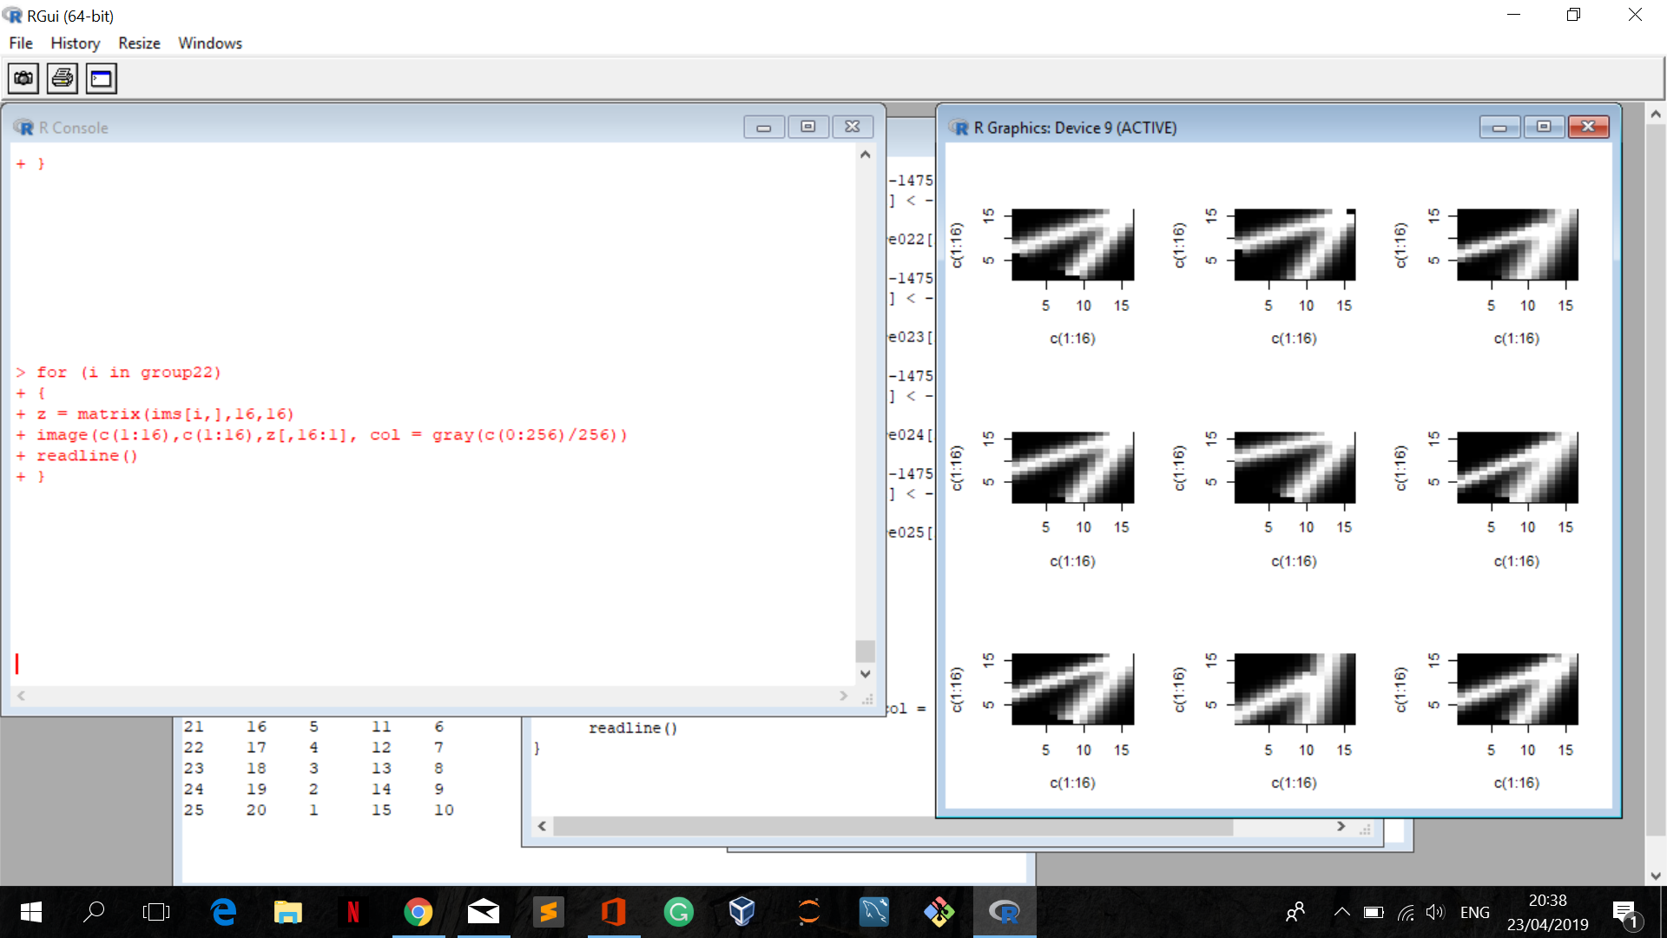←------First generation

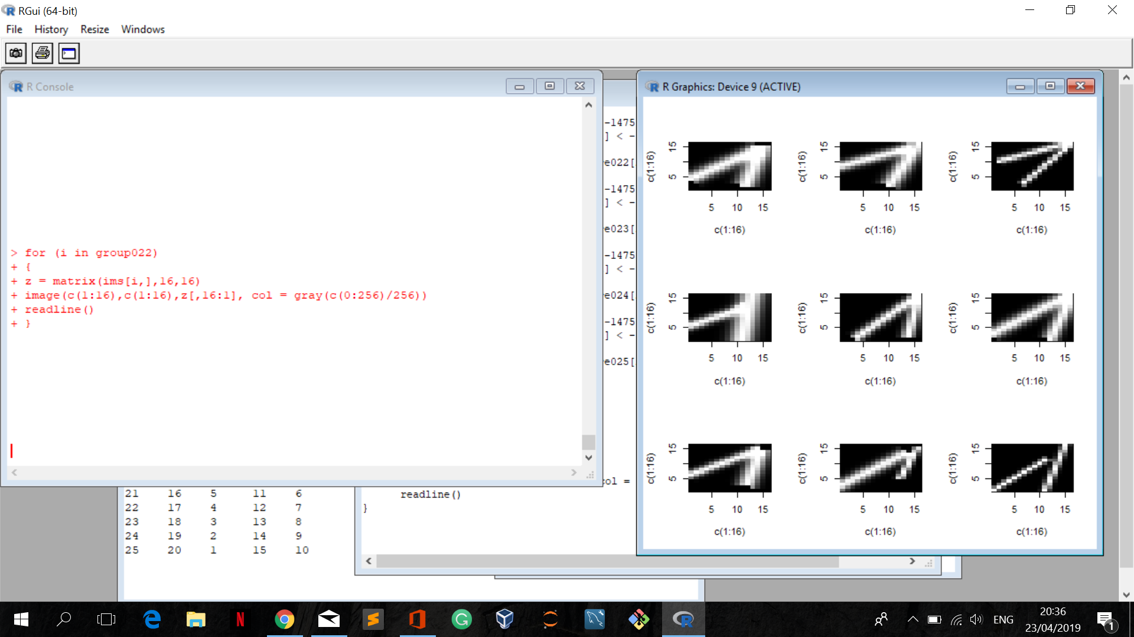←------Second generation

* The following are 9 images from the middle center-right square in both the distribution of the first and second generation of 1’s.

←------First generation

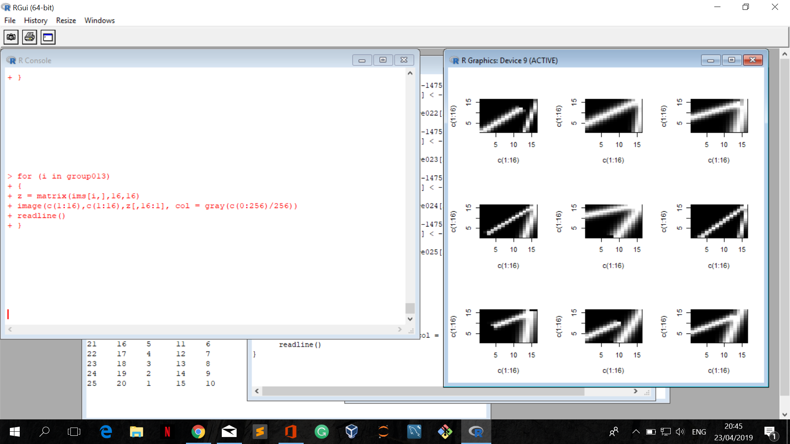←------Second generation

* All 4 of these squares have very similar images between the 2 sets of generated 1’s.
* The only thing that I found to be of any significant difference between the images seen above was the stroke thickness.
* The angles were similar along with the stroke lengths and the starting points.
* The thickness was sometimes bigger in the first set and sometimes bigger in the second set so I could not pinpoint the reason for the difference.
* I then compared the means of the feature vectors.
* While I had saved the indexes of the images that lay in each of the squares in the first distribution, I first had to find the indexes of the images that lay within these squares from the second distribution.
* I did this using the following code:

*group01 = index[p3[,1] > -25 & p3[,1] < 125 & p3[,2] > -450 & p3[,2] < 600]*

*group02 = index[p3[,1] > -275 & p3[,1] < -25 & p3[,2] > -275 & p3[,2] < -125]*

*group03 = index[p3[,1] > -25 & p3[,1] < 125 & p3[,2] > 50 & p3[,2] < 200]*

*group04 = index[p3[,1] > -25 & p3[,1] < 125 & p3[,2] > 375 & p3[,2] < 525]*

*group05 = index[p3[,1] > -25 & p3[,1] < 125 & p3[,2] > 700 & p3[,2] < 850]*

*group06 = index[p3[,1] > 1425 & p3[,1] < 1575 & p3[,2] > 700 & p3[,2] < 850]*

*group07 = index[p3[,1] > 1425 & p3[,1] < 1575 & p3[,2] > 375 & p3[,2] < 525]*

*group08 = index[p3[,1] > 1425 & p3[,1] < 1575 & p3[,2] > 50 & p3[,2] < 200]*

*group09 = index[p3[,1] > 1425 & p3[,1] < 1575 & p3[,2] > -275 & p3[,2] < -125]*

*group010 = index[p3[,1] > 1425 & p3[,1] < 1575 & p3[,2] > -600 & p3[,2] < -450]*

*group011 = index[p3[,1] > 750 & p3[,1] < 900 & p3[,2] > 700 & p3[,2] < 850]*

*group012 = index[p3[,1] > 750 & p3[,1] < 900 & p3[,2] > 375 & p3[,2] < 525]*

*group013 = index[p3[,1] > 750 & p3[,1] < 900 & p3[,2] > 50 & p3[,2] < 200]*

*group014 = index[p3[,1] > 750 & p3[,1] < 900 & p3[,2] > -600 & p3[,2] < -450]*

*group015 = index[p3[,1] > 750 & p3[,1] < 900 & p3[,2] > -275 & p3[,2] < -125]*

*group016 = index[p3[,1] > -800 & p3[,1] < -650 & p3[,2] > -600 & p3[,2] < -450]*

*group017 = index[p3[,1] > -800 & p3[,1] < -650 & p3[,2] > -275 & p3[,2] < -125]*

*group018 = index[p3[,1] > -800 & p3[,1] < -650 & p3[,2] > 50 & p3[,2] < 200]*

*group019 = index[p3[,1] > -800 & p3[,1] < -650 & p3[,2] > 375 & p3[,2] < 525]*

*group020 = index[p3[,1] > -800 & p3[,1] < -650 & p3[,2] > 700 & p3[,2] < 850]*

*group021 = index[p3[,1] > -1475 & p3[,1] < -1325 & p3[,2] > 700 & p3[,2] < 850]*

*group022 = index[p3[,1] > -1475 & p3[,1] < -1325 & p3[,2] > 375 & p3[,2] < 525]*

*group023 = index[p3[,1] > -1475 & p3[,1] < -1325 & p3[,2] > 50 & p3[,2] < 200]*

*group024 = index[p3[,1] > -1475 & p3[,1] < -1325 & p3[,2] > -275 & p3[,2] < -125]*

*group025 = index[p3[,1] > -1475 & p3[,1] < -1325 & p3[,2] > -600 & p3[,2] < -450]*

* I compared them using the following code replacing “XX” with the respective square number and “YY” with the number of rows in the feature vectors after they are generated.

*# create feature vector for 1st generation*

*vec = matrix(0,10,1)*

*for (i in groupXX)*

*{*

*vec = cbind(vec, params[i,])*

*}*

*# create feature vector for 2nd generation*

*feat = matrix(0,10,1)*

*for (i in group0XX)*

*{*

*feat=cbind(feat, params2[i,])*

*}*

*# delete the first row of zeros from initialisation*

*vec = vec[ ,2:YY]*

*feat = feat[ ,2:YY]*

*# get the means (across the rows)*

*mfeat = apply(feat, 1, mean)*

*mvec = apply(vec, 1, mean)*

*# Display the means of the feature vectors and the difference between them*

*mfeat*

*mvec*

*mvec - mfeat*

* I then ran this above code on the 4 squares that I had randomly selected from the distribution to compare their feature vectors.
* The following are the means of the feature vectors from the images in the **bottom left square** in both the distribution of the first and second generation of 1’s along with the difference between the 2 sets of means of these feature vectors.

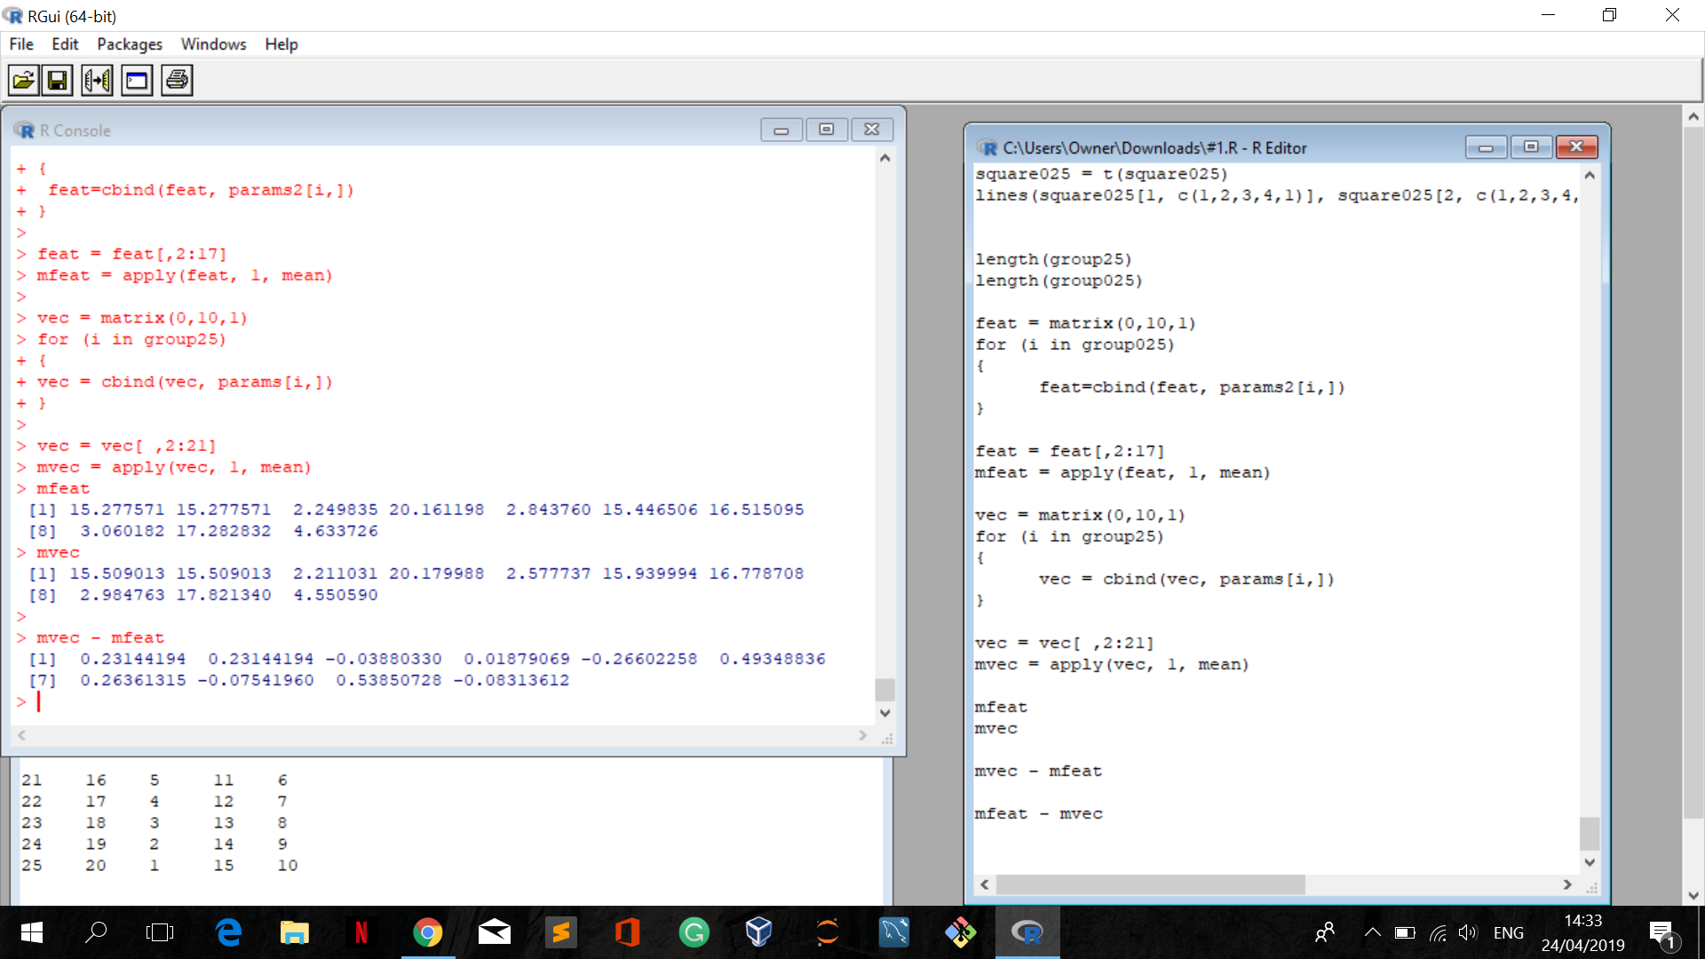

* The following are the means of the feature vectors from the images in the **bottom center-right square** in both the distribution of the first and second generation of 1’s along with the difference between the 2 sets of means of these feature vectors.

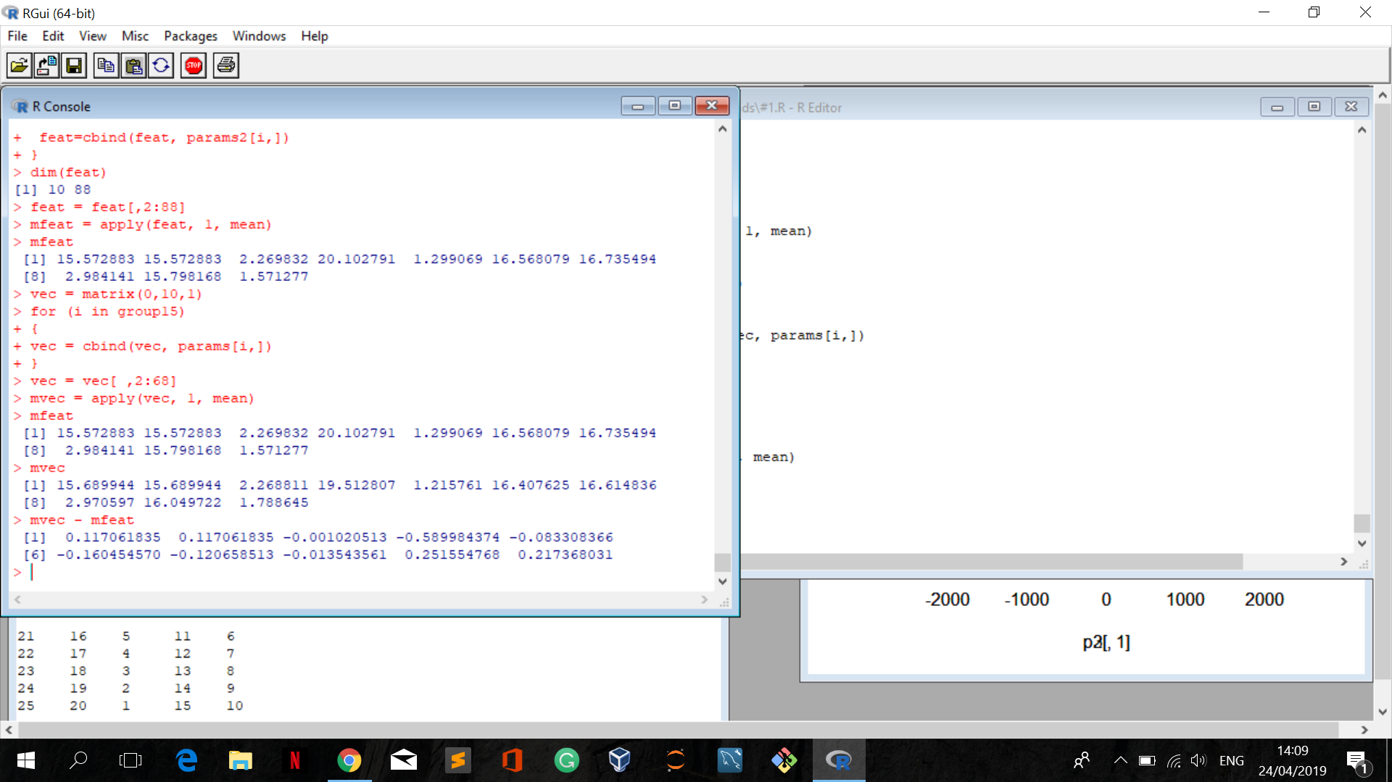

* The following are the means of the feature vectors from the images in the **left upper-center square** in both the distribution of the first and second generation of 1’s along with the difference between the 2 sets of means of these feature vectors.

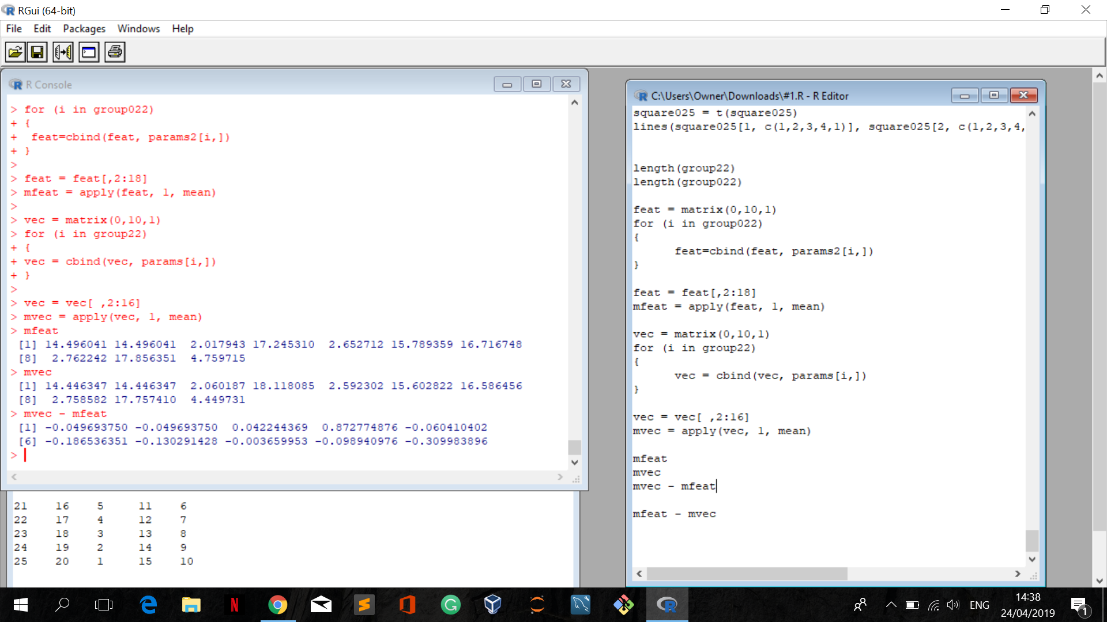

* The following are the means of the feature vectors from the images in the **middle center-right square** in both the distribution of the first and second generation of 1’s along with the difference between the 2 sets of means of these feature vectors.

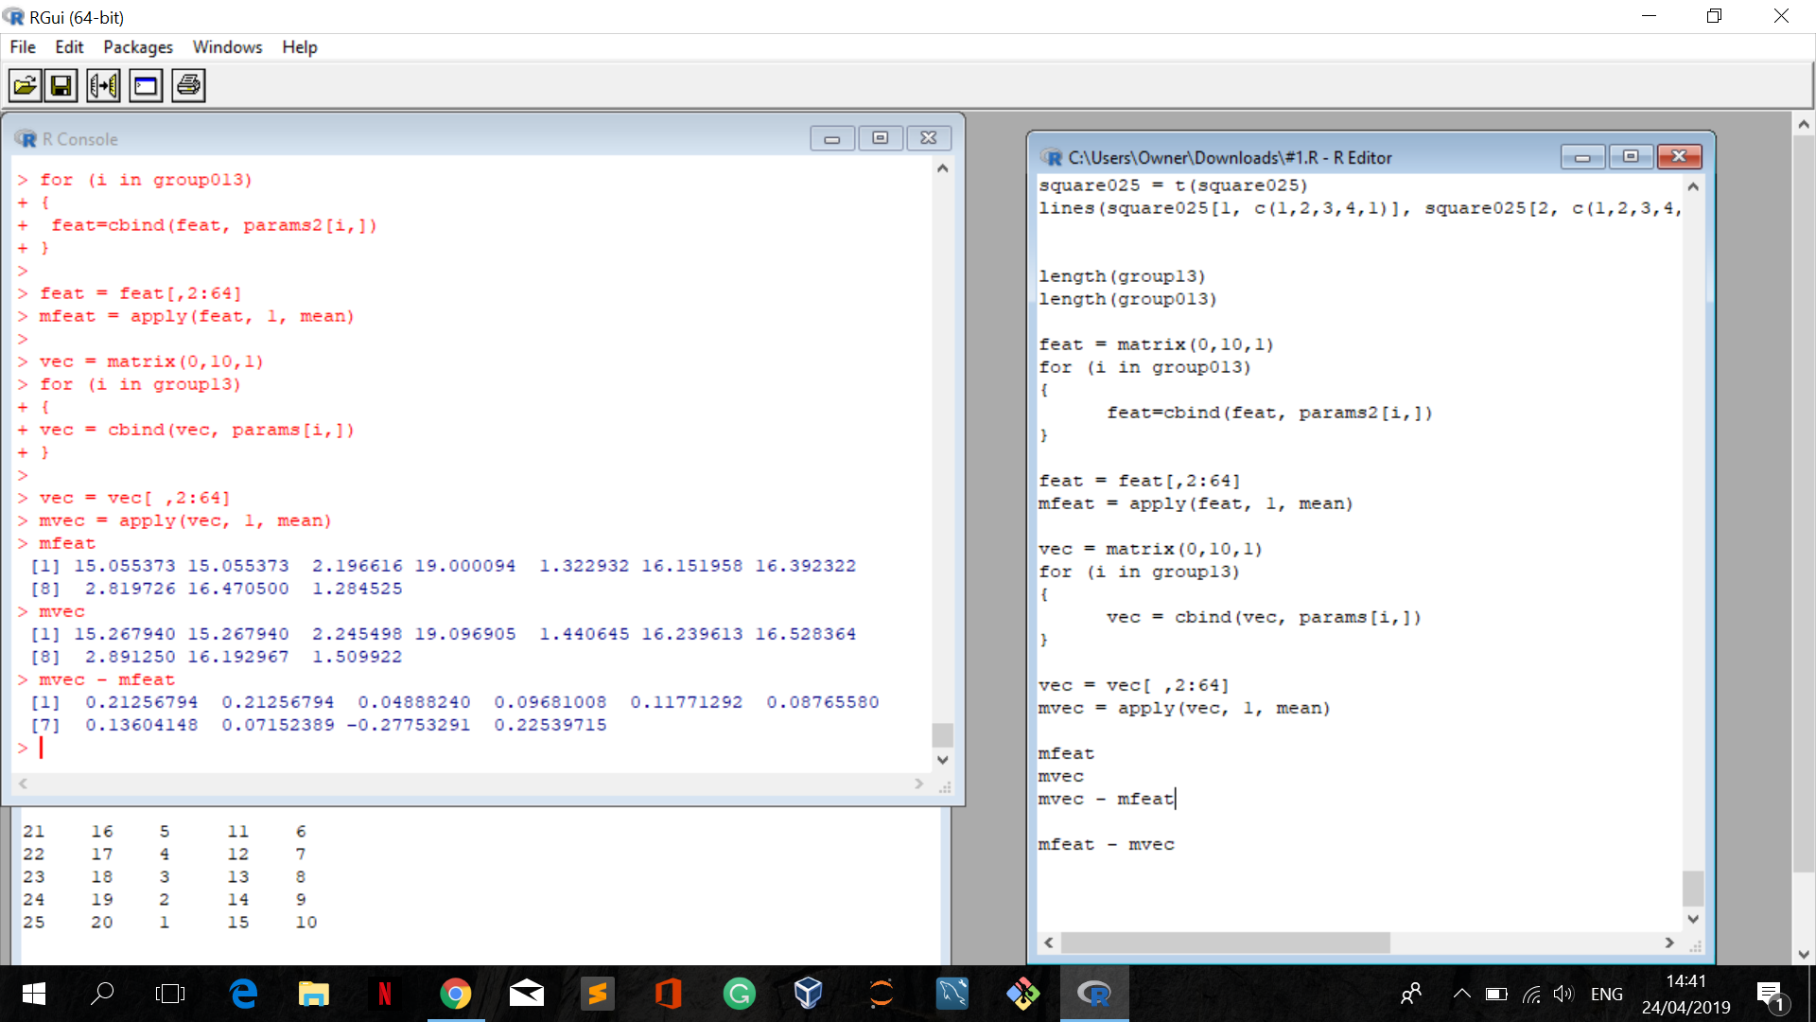

* The difference between these feature vectors’ means are all very close to zero which backs up the thought that these sets of generated 1’s are petty similar and that the means of each feature in the feature vectors would have little difference between the different generations.
* Some mean values are more different than others which shows the small difference between the randomly generated numbers, however, most are quite similar which is expected.